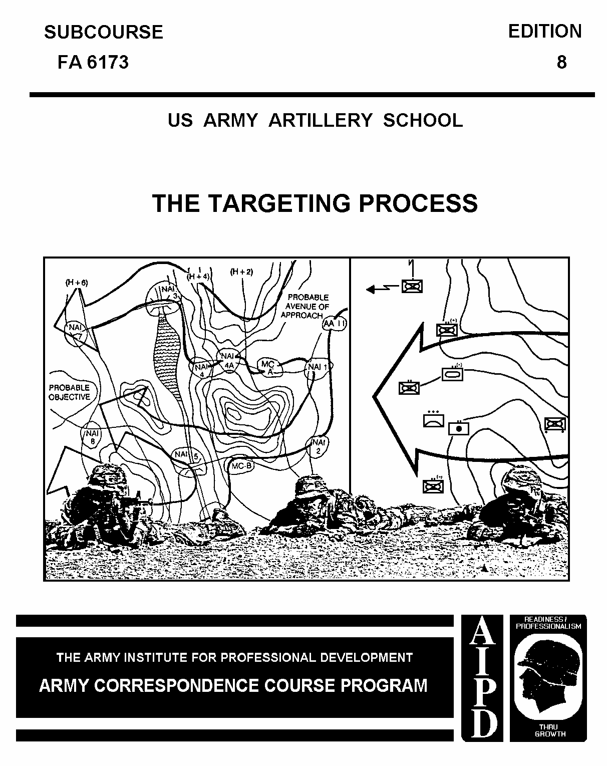

CANNON FIELD ARTILLERY OFFICER
MOS 13E, MQS II

THE TARGETING PROCESS

SUBCOURSE FA 6173

US Army Field Artillery School
Fort Sill, Oklahoma

EDITION 8
6 CREDIT HOURS
REVISED: 1988

This subcourse is designed to train the skills necessary for performing tasks
related to the targeting process. This subcourse is presented in five lessons,
corresponding to the terminal objectives supporting the following tasks from the
Military Qualification Standard Manual 13E II.

LESSON 1: Decide-Detect-Deliver

TASK NO: 01-2840.00-2004

TASK: Describe the field artillery fire planning process.

CONDITIONS: TBD

STANDARDS: TBD

LESSON 2: The Targeting Cell at Corps, Division, and Brigade

TASK NO: 01-2840.00-2002

TASK: Identify the fire support coordination structure.

CONDITIONS: TBD

STANDARDS: TBD

LESSON 3: Target Acquisition and Attack Systems at Corps, Division, and Brigade

TASK: Not applicable.

LESSON 4: Tools of the Targeting Process

TASK NO: 01-2840.01-0005

TASK: Analyze targets to determine target categories through the use of
target value analysis (TVA) procedures.

CONDITIONS: Given a list of the thirteen categories, a list of the 128
targets sheets from the original TVA study, and a list of
targets.

STANDARDS: Determine the appropriate target category for each target IAW
FC 6-20-10, without error.

TASK NO: 01-2840.00-2017

TASK: Determine high payoff targets and develop attack guidance through
the use of target value analysis (TVA) procedures.

CONDITIONS: Given a tactical situation, TVA spread sheet, target sheet and
operations order, IPB results, and the commander's guidance.

STANDARDS: Determine high value and payoff targets and develop the attack
guidance for the operation IAW FC 6-20-10, without error.

LESSON 5: TACFIRE Overview

TASK: Not applicable

TABLE OF CONTENTS

TITLE PAGE

TABLE OF CONTENTS

Lesson 1: Decide-Detect-Deliver

Introduction

Overview of Targeting Process

Decide

Detect

Deliver

Summary

Lesson 2: The Targeting Cell at Corps, Division, and Brigade

Introduction

Corps Targeting Cell

Division Targeting Cell

Div Arty TOC/Field Artillery Brigade

Brigade Targeting Cell

Summary

Lesson 3: Target Acquisition and Attack Systems at Corps, Division, and Brigade

Introduction

Summary

Lesson 4: Tools of the Targeting Process

Introduction

Spread Sheets

Target Sheets

High-Payoff Target Matrix

Attack Guidance Matrix

Target Selection Standards Matrix

Doctrinal Template

Situation Template

Event Template

Decision Support Template

Summary

Lesson 5: TACFIRE Overview

Introduction

High-Payoff Target Matrix and TACFIRE

Attack Guidance Matrix and TACFIRE

Target Selection Standards Matrix and TACFIRE

Summary

EXAMINATION

APPENDIX A: Detect and Deliver Systems From Company to Corps

APPENDIX B: Spread Sheet

APPENDIX C: Target Sheet

APPENDIX D: High-Payoff Target Matrix

APPENDIX E: Attack Guidance Matrix

APPENDIX F: Target Selection Standards Matrix

APPENDIX G: Doctrinal Template

APPENDIX H: Situation Template

APPENDIX I: Event Template

APPENDIX J: Decision Support Template

Supplementary requirements. The following subcourses should be completed before
taking this subcourse: FA 6171, Target Acquisition and FA 6172, Targeting
Procedures in the Division Artillery Tactical Operations Center and the Field
Artillery Brigade Headquarters.

Lesson 1
DECIDE-DETECT-DELIVER

OBJECTIVE

Upon completion of this lesson, you will be able to:

a. Determine what is meant by decide-detect-deliver.

b. Explain how decide-detect-deliver fits into the field artillery fire
planning process.

REFERENCES

This lesson is based on TC 6-20-10 (to be published). However, development and
progress render the text continually subject to change. Therefore, base your
examination answers on material presented in this text rather than on individual
or unit experience.

1. INTRODUCTION. The targeting process used to support today's AirLand Battle
revolves around the concept of decide-detect-deliver. This concept ties into the maneuver commander's decision-making process and is based on his concept of
operation.

2. OVERVIEW OF THE TARGETING PROCESS.

a. Targeting is the process of selecting targets and matching the
appropriate response, taking into account operational requirements and capabilities. An efficient, organized targeting effort is critical to the success of AirLand Battle operations. Attacking targets that the enemy can least afford to lose strips him of the initiative and forces him to conform to our battle plans.

b. Targeting is a complex, multidiscipline effort, requiring interaction
between fire support, intelligence, and plans cells. This interaction is
necessary to synchronize the planning, acquisition, and attack of targets.
Representatives from these cells form the core of the targeting cell and should
be assisted by other cells in the planning and execution of targeting.

c. The objective of targeting is to help the maneuver disrupt, delay, or
limit those enemy capabilities which could interfere with the achievement of our
objectives.

d. Targeting is based on the friendly scheme of maneuver and tactical plan
(mission, enemy, terrain and weather, troops and time available [METT-T] and
commander's intent) and includes an assessment of the weather, terrain, and enemy to identify those enemy formations, equipment, facilities, and terrain which must be attacked or controlled to ensure success.

e. Targeting is an integral part of the planning process which begins with
the receipt of a mission and continues through the development of the approved
plan.

f. The targeting process includes the development of a prioritized list
specifying what targets are to be acquired and attacked, when they are to be
acquired and attacked, and what is required to defeat the target.

g. This process supports the maneuver commander's decision on which attack
option and echelon will be used to engage the target. An assessment is then
conducted (target damage assessment [TDA]), if originally planned to determine
the effectiveness of the engagement.

h. Although more commonly associated with high- and medium-intensity
conflicts, the targeting process does apply to low-intensity conflict (LIC).
While LIC spread sheets and target sheets do not currently exist, the concept of
target cell personnel meeting together to determine the most important targets to strike in support of the friendly maneuver commander (high-payoff targets [HPTs]) as well as how to detect and attack those targets (target selection standard [TSS] and attack guidance matrix) still applies.

i. The targeting methodology can be characterized as decide-detect-
deliver. These three functions must be intertwined.

3. DECIDE.

a. From the standpoint of targeting, the fire support, intelligence, and
maneuver estimates are interrelated and require close coordination. The decide
function addresses priorities as they apply to the tasking of target acquisition
assets, information processing, the selection of an attack system, and the
requirement for TDA.

b. The decide function should answer the following questions:

(1) What is it we need to look for?

(2) Where and when can it be found?

(3) Who can locate and identify it?

(4) Which attack option should be used?

(5) Will TDA be required or possible?

4. DETECT.

a. The priorities developed in the decide function are translated into
target acquisition (TA) taskings, which will appear in the TA collection plan.
These TA assets gather information and report their findings to their controlling headquarters. The controlling headquarters then passes pertinent information to the tasking agency.

b. Not all of the information will immediately benefit the targeting
effort. However, it may be valuable in developing the overall situation, and
eventually, producing beneficial targets. As these targets are developed,
appropriate attack systems are tasked in accordance with the predetermined
commander's guidance and requirements of the attack system managers.

5. DELIVER. The main objective of this function is the attack of targets.
This is accomplished by the selection of an attack system or combination of
attack systems. If TDA reveals that the maneuver commander's attack guidance has not been met, then the targeting process should continue to focus on this target.

PRACTICE EXERCISES:

Complete the following exercises by circling T for true or F for false, circling
the letter preceding the correct answer, or filling in the blanks, as appropriate. Be sure to complete the practice exercises as they appear. They
are "building blocks" that will help you complete the rest of the subcourse
successfully. The answers follow the last exercise and are separated by rows of
slashes (//////). If any of your answers are incorrect, restudy the appropriate
part of the subcourse before you continue.

1. Targeting requires interaction, as a minimum, between which cells?

a. fire support, intelligence, and logistics
b. fire support, plans, and logistics
c. communications, intelligence, and plans
d. fire support, intelligence, and plans

2. The targeting process is described by what concept?

a. detect-decide-deliver
b. decide-detect-destroy
c. decide-detect-deliver
d. decide-deliver-destroy

3. On what is targeting based?

a. friendly scheme of maneuver
b. commander's intent
c. concept of the operation
d. all of the above

4. Decide-detect-deliver is appropriate for what types of conflicts?

a. low-, medium-, and high-intensity conflicts
b. low- and medium-intensity conflicts only
c. medium- and high-intensity conflicts only
d. high-intensity conflicts only

5. During which function of the targeting process is the requirement for TDA
determined?

a. detect
b. decide
c. deliver
d. develop

6. During which function of the targeting process are priorities turned into
target acquisition tasking?

a. decide
b. detect
c. deliver
d. develop

7. Actual TDA is compared to commander's attack guidance after which function
of the targeting process?

a. decide
b. detect
c. deliver
d. destroy

//////////////////////////////////////////////////////////////////////////////

ANSWERS:

1. d.
2. c.
3. d.
4. a.
5. b.
6. b.
7. c.

//////////////////////////////////////////////////////////////////////////////

6. SUMMARY. During this lesson, you have been introduced to targeting and the
targeting process. Remember that the targeting process is continuous and is
represented by three functions: decide-detect-deliver. These functions should
always be executed in this order.

Lesson 2
THE TARGETING CELL AT CORPS, DIVISION, AND BRIGADE

OBJECTIVE

Upon completion of this lesson, you will be able to:

a. Describe the concept of the targeting cell at the various echelons and
the responsibilities of the personnel involved.

b. Identify how the targeting cell fits into the fire support
coordination structure.

REFERENCES

This lesson is based on TC 6-20-10 (to be published). However, development and
progress render the text continually subject to change. Therefore, base your
examination answers on material presented in this text rather than on individual
or unit experience.

7. INTRODUCTION.

a. It is important to understand that while the appearance of the
targeting cell concept in written doctrine may be new, its use is not. When
material for TC 6-20-10 was being gathered, the authors found that several corps
and divisions were using concepts similar to the targeting cell. Some called it
a deep attack cell while others referred to it in their SOPs as a regular
meeting of key personnel for planning. Regardless of what it is called, it is
important to realize that this targeting cell concept is not a drastic change to
the way we have been doing the targeting business in recent years. All FM 6-20-
10 has done is settle on one term--the targeting cell--so that we in the
targeting business can be sure we are talking the same language.

b. So what is the targeting cell? It is an informal group of planners who
meet as often as necessary to facilitate targeting at all levels. The concept
requires no additional assets in terms of personnel and/or equipment.

c. The targeting cell is not only a wartime organization. The cell must
be exercised before battle if it is to operate effectively. The members of the
targeting cell must be familiar with the other players and their roles within the cell.

d. A maneuver commander's staff must perform three basic functions:

- Planning (operations).

- Targeting.

- Intelligence.

e. We normally think of operations and intelligence as being a G3/G2
responsibility. However, the targeting process can be improved by integrating
the maneuver commander, G3, G2, and fire support element (FSE) into an informal
targeting cell. The cell would be located in the main tactical operations center (TOC). Other staff elements will be involved as necessary.

f. The assistant fire support coordinator (AFSCOORD) at division and
higher and the fire support officer (FSO) at brigade and below should be in
charge of the targeting cell. The cell will meet on an as-needed basis to
enhance the targeting process.

g. We locate the targeting cell in the main TOC to reinforce the AirLand
Battle premise that the staff should synchronize the battle near the FSE and G2.
This is because the evaluation of attack options is closely tied to the
availability of intelligence information. Also, the FSE manages the majority of
attack assets and is the ultimate executor.

h. The targeting cell has three primary functions in assisting the
maneuver commander:

(1) Synchronize the close, deep, and rear targeting operations. (The
cell allows the maneuver commander to allocate assets to each operation and fight them at the same time.)

(2) Recommend targets for acquisition and attack. (Recommending HPTs
includes not only nominating targets for detection or attack but also recommending the allocation of assets to detect and attack these HPTs.)

(3) Recommend which targets require TDA.

i. The targeting effort is continuous, and this continuity is achieved by
a chain of targeting cells from corps down to battalion task force level. We
have already stated that the intelligence, operations, and FSE personnel form the core of the targeting cell at all echelons. However, other staff officers will participate on an as-needed basis.

8. CORPS TARGETING CELL.

a. Before targeting at the corps targeting cell can be accomplished, the
battle must be handed over to corps from echelons above corps (EAC). This is
accomplished by the use of phase lines/planning lines. Corps can still nominate
targets to EAC, and EAC will help corps by approving those nominations as the
tactical situation dictates.

b. In the past, there has been a tendency to divide battlefield
responsibilities between the tactical and main command posts (CPs) with the
tactical focusing on current, close operations while the main planned for the
deep and/or future operations. AirLand Battle doctrine emphasizes the need to
have the staff synchronize operations--a function the corps targeting cell can
do. This cell has the necessary assets to see, plan, and execute deep targeting
operations while synchronizing targeting in support of deep, close, and rear
operations.

c. The tremendous variety of corps contingencies and operating
environments requires that the formal structure of the elements at corps be
modified to meet the commander's needs. Regardless of the tailoring done,
however, certain key personnel should be involved in the targeting effort.

d. TC 6-20-10 states that while the corps commander and his FSCOORD are
important influences on the targeting process, they are not members, per se, of
the targeting cell.

e. The key personnel and agencies in the targeting cell at corps are as
follows:

- Corps AFSCOORD.

- G2 representative.

- Target analysts from the FSE.

- Field artillery intelligence officer (FAIO).

- Fighter liaison officer (FLO).

- United States Air Force (USAF) intelligence officer.

- G3 representative.

- Engineer representative.

- Electronic warfare officer.

- Nuclear, biological, chemical (NBC) officer.

f. The responsibilities of personnel and agencies are as follows:

(1) The corps commander--

(a) Issues guidance on the concept of operation for close, deep,
and rear area operations.

(b) Defines the corps mission.

(c) Designs the corps concept of operation.

(d) States his intent.

(e) Assigns missions and reinforcing units to his subordinates.

(f) Determines where the main effort will be and who will be
responsible for it.

(g) Sets corps objectives.

(h) Guides the actions of the corps targeting cell with his
intentions and objectives.

(2) The corps fire support coordinator (FSCOORD) (corps artillery
commander)--

(a) Is the primary advisor to corps commander on all fire support matters.

(b) Recommends artillery organization for combat.

(c) Establishes and supervises the FSE.

(d) Plans and synchronizes fire support.

(e) Prepares fire support portion of the corps operations order.

(3) The corps AFSCOORD (two each at main TOC and two each at tactical
TOC)--

(a) Supervises the targeting cell.

(b) Recommends HPT matrix to the corps FSCOORD.

(c) Develops the attack guidance formulated by the corps
commander and FSCOORD.

(d) Maintains status of fire support resources and plans their
employment.

(e) Develops targets.

(f) Uses target value analysis (TVA) to identify target
priorities.

(g) Analyzes targets for attack with nuclear and/or chemical
weapons.

(h) Recommends target priorities for acquisition and attack.

(i) Determines, with the electronic warfare section (EWS),
targets for attack.

(j) Determines minimum information required for each attack.

(k) Determines, with the G2, targets for acquisition.

(l) Determines fire support means to attack target.

(m) Coordinates suppression of enemy air defenses (SEAD).

(n) Monitors changes in the situation that could effect target
priorities.

(o) Receives TDA.

(p) Ascertains, with the G2, if desired effects were achieved.

(q) Determines if additional attacks are required.

(r) Coordinates timing of attack with the G3.

(4) The G2 representative--

(a) Analyzes and develops targets based on commander's guidance.

(b) Predicts probable enemy actions based on intelligence
preparation of the battlefield (IPB).

(c) Develops enemy situation.

(d) Develops target priorities for acquisition.

(e) Identifies high-value targets.

(f) Assists FSE in developing target priorities.

(g) Determines TSS with the FSE.

(h) Passes HPTs to FSE that targeting cell has decided to attack.

(i) Develops IPB templates.

(j) Analyzes TDA information.

(5) The target analysts (two each)--

(a) Analyze targets for possible attack by nuclear and/or
chemical weapons.

(b) Perform nuclear target analysis and aimpoint refinement as
part of corps nuclear package planning effort.

(c) Advise AFSCOORD on troop safety, collateral damage, and
nuclear weapons effects.

(d) Help AFSCOORD with conventional planning.

(6) The field artillery intelligence officer--

(a) Works with corps support element (CSE) selecting critical
target information.

(b) Understands the threat, TSS, attack guidance, and list of HPT types.

(c) Specifies most important targets for which intelligence
analysts should be looking and when those targets are critical to the targeting
effort.

(d) Provides detailed information regarding accuracy and
timeliness requirements.

(7) The fighter liaison officer--

(a) Helps develop and evaluate targets.

(b) Advises on suitability of targets for attack.

(c) Advises on best aircraft ordnance to attack the target.

(d) Coordinates with FSE for SEAD.

(8) The G3 representative--

(a) Concentrates on future and contingency operations.

(b) Ensures all plans reflect the commander's concept of
operation.

(c) Influences the determination of HPTs.

(9) The engineer representative--

(a) Advises on attack of deep targets with scatterable mines.

(b) Provides status on scatterable mine munitions.

(10) The electronic warfare officer--

(a) Recommends electronic countermeasures (ECM) and electronic
warfare support measures (ESM) requirements that will support commander's intent.

(b) Plans and coordinates tasking and requests to satisfy ECM and ESM requirements.

(c) Assists all-source production section (ASPS) in their portion of IPB--specifically electronic preparation of the battlefield.

(d) Recommends electronic warfare (EW) actions to support the
friendly communications, command, and control countermeasures (C3CM) strategy.

(e) Prepares EW estimates and annexes and develops ECM mission
tasking.

(11) The Air Force intelligence officer--

(a) Provides USAF input to analysis and plans.

(b) Collects, processes, exploits, and disseminates air
intelligence.

(c) Provides signals intelligence support.

(d) Provides intelligence support to electronic combat.

(e) Provides Air Force priority intelligence requirements (PIRs)
to intelligence collection assets.

(f) Interprets intercepted communications and signals.

(g) Identifies, analyzes, and tabulates information from
multisensor imagery.

(12) The NBC officer--

(a) Develops chemical and nuclear targets.

(b) Assists in evaluating targets.

(c) Advises on suitability of targets for attack.

(d) Provides guidance on the type and quantity of nuclear and
chemical rounds suitable to engage a target.

9. DIVISION TARGETING CELL.

a. Division is the lowest echelon that has any significant deep-strike
capability. Because of this, the targeting cell at division will primarily focus its efforts on deep operations. As at all echelons, IPB, TVA, and the war-gaming process are continuous and will result in the commander's estimate and course of action (COA) selection. After the COA is selected by the division commander, the division FSCOORD will write the fire subparagraph of the operations order (OPORD) and the fire support plan.

b. The division FSCOORD should develop, in conjunction with the G2 and G3,
the HPT matrix and attack guidance matrix. The HPT matrix will be used by the
division acquisition and attack system for prioritizing its target processing.
The attack guidance matrix converts the division commander's desires and
requirements into specifications for the fire support system as a whole.

c. The division targeting cell is both a planner and an executor. Since
its primary function is to plan and execute deep targeting operations, it is a
logical element to coordinate deep targeting operations with close and rear
targeting operations.

d. The division commander and his FSCOORD, while important influences on
the targeting process, are not members, per se, of the targeting cell.

e. The key personnel and agencies in the targeting cell at division are as
follows:

- AFSCOORD.

- G2 representative.

- FAIO.

- G3 representative.

- Electronic warfare officer.

- Targeting analyst.

- Army airspace command and control (AýCý) representative.

- Air liaison officer (ALO).

- NBC officer.

- Engineer representative.

- Naval gunfire officer (NGLO).

f. The responsibilities of the personnel and agencies are as follow:

(1) The division commander--

(a) Issues guidance on the concept of operation for close, deep,
and rear operations.

(b) Defines the division mission.

(c) Designs the division concept of operation.

(d) States his intent.

(e) Assigns missions and reinforcing units to his subordinates.

(f) Determines where the effort will be and who will be
responsible for it.

(g) Sets division objectives.

(h) Guides the actions of the division targeting cell with his
intention and objectives.

(2) The division FSCOORD--

(a) Is the primary advisor to the division commander on all fire
support matters.

(b) Recommends artillery organization for combat.

(c) Establishes and supervises the FSE.

(d) Plans and synchronizes fire support.

(e) Prepares fire support portion of the division operations
order.

(3) The division AFSCOORD--

(a) Supervises the targeting cell.

(b) Supervises the division close, deep, and rear targeting
operations.

(c) Supervises the planning and execution of the division depth
operations.

(d) Develops and maintains high-value target (HVT) lists and HPT
lists in conjunction with the G3/G2 representatives.

(e) Coordinates target list execution.

(f) Determines and recommends the division attack guidance matrix to the FSCOORD.

(g) Supervises implementation of attack guidance within the
targeting cell, FSE and division artillery (div arty) TOC.

(h) Runs the daily operations of the targeting cell.

(i) Helps G2 representative determine accuracy requirements and
targets which are time sensitive.

(4) The G2 representative--

(a) Develops enemy situation.

(b) Identifies HVTs and develops targets for attack.

(c) Assists FSE in developing target priorities.

(d) Determines TSS with the FSE.

(e) Develops IPB templates.

(f) Provides targets to the FSE for attack.

(g) Analyzes TDA information.

(5) The G3 representative--

(a) Ensures commander's concept and intent are incorporated into
the TVA process.

(b) Helps develop the HPT matrix in conjunction with the G2
representative and AFSCOORD.

(c) Informs brigade S3s of division HPTs.

(d) Helps develop the attack guidance matrix in conjunction with
the AFSCOORD.

(e) Helps G2 representative determine accuracy and time
requirements for target.

(6) The electronic warfare officer--

(a) Assists the ASPS in determining EW HVTs and HPTs.

(b) Determines accuracy and time requirements for targets in
conjunction with the AFSCOORD.

(c) Translates time requirements into mission guidance for the EW systems under division control.

(d) Recommends the EW method of target engagement, if applicable.

(e) Helps determine the HPT matrix in conjunction with the
AFSCOORD and G3 representative.

(f) Prepares EW estimate and annex (to include restricted
frequency list).

(7) The targeting analyst--

(a) Serves as primary advisor to the AFSCOORD regarding the
development of the attack guidance matrix.

(b) Recommends HVTs and HPTs.

(c) Provides TDA.

(8) The Army airspace command and control (AýCý) representative--

(a) Advises on attack helicopter and air defense asset use.

(b) Provides expertise on Army aviation assets for deep
operations.

(c) Coordinates routes to and from deep targets for aircraft.

(9) The field artillery intelligence officer--

(a) Works with division support element (DSE) in selecting
critical target information.

(b) Understands the threat, TSS, attack guidance, and the list of HPT types.

(c) Specifies most important targets for which intelligence
analysts should be looking and when these targets are critical to the targeting
effort.

(d) Provides detailed information regarding accuracy and
timeliness requirements.

(10) The air liaison officer--

(a) Advises on aircraft status and use.

(b) Provides expertise on Air Force aviation assets for deep
operations.

(c) Coordinates, with AýCý representative, routes to and from
deep targets for aircraft.

(11) The NBC officer--

(a) Recommends deep targets for chemical and nuclear attack.

(b) Provides status of chemical and nuclear assets.

(12) The engineer representative--

(a) Recommends deep targets for attack with scatterable mines.

(b) Provides status on scatterable mine munitions.

(13) The naval gunfire liaison officer--

(a) Recommends organization for combat for fire support ships.

(b) Recommends locations or zones for fire support stations or
ships.

10. DIV ARTY TOC/FIELD ARTILLERY BRIGADE.

a. The div arty TOC/field artillery (FA) brigade still focuses on two of
the three artillery roles: counterfire and interdiction. Close support will be
the responsibility of direct support (DS) or reinforcing (R) battalions. The
formation of the informal targeting cell found at the division main TOC in no way decreases the div arty TOC/FA brigade responsibilities. If the targeting cell at division determines a target should be engaged with artillery, it will forward that target through fire support channels to the div arty TOC/FA brigade.

b. The div arty TOC/FA brigade is represented in the targeting process by
the AFSCOORD at division. He ensures that the div arty TOC/FA brigade remains
an active executor of the division commander's guidance as it is represented by
three tools:

- The HPT matrix.

- The attack guidance matrix.

- The TSS matrix.

The AFSCOORD ensures that these three tools are delivered to the div arty TOC/FA
brigade.

c. The primary mission of the div arty TOC/FA brigade continues to be
counterfire and interdiction for the division. They use the three tools from
division as guidance in developing their own TSS matrix. The HPT matrix and
attack guidance matrix from division should remain unchanged.

d. The div arty TOC/FA brigade attack guidance matrix and TSS are
distributed to the FA battalions under their control. These will be used in the
battalion and battery fire direction centers (FDCs) to aid the identification of
targets and delivery of fires. The HPT matrix can be helpful at battalion or
battery level to resolve the problem of simultaneous missions with the same
"when" guidance. A copy of the div arty TOC/FA brigade attack guidance matrix
and TSS are sent to the division AFSCOORD in the targeting cell to keep him
informed.

11. BRIGADE TARGETING CELL.

a. Targeting at the brigade level is keyed to close operations, the nature
and posture of the opposing force, and the resources available to the commander.
Targets of interest are primarily tactical command and control centers, small
combat and combat support units, and terrain of immediate concern to the brigade.

b. Brigade-level targeting is accomplished by an informal targeting cell
comprised of the brigade commander, S3, S2, FSO, targeting officer, and
intelligence and electronic warfare staff element (IEWSE) (organic to the
military intelligence [MI] battalion). This cell also could have representa-
tives from the engineers, chemical, the aviation brigade, the Air Force, and the
Navy if those units are in support of the brigade.

c. The key personnel and agencies in the targeting cell at brigade are as
follows:

- Brigade commander.

- Brigade S2 and S3.

- Brigade FSE, to include the FSO and the targeting officer.

- The IEWSE.

d. Other personnel who may be involved in the brigade targeting process
are as follows:

- Other members of the FSE, to include the ALO, NGLO, NBC officer,
and S3 air.

- FSCOORD (DS battalion commander).

- DS battalion S2 and S3.

e. The responsibilities of the personnel and agencies are as follows:

(1) The brigade commander—

- Provides guidance on his concept of operation, important
targets, and effects he wants on those targets.

(b) Defines the brigade mission and his intent.

I Assigns missions to his subordinates.

- Determines where the main effort will be and who will be
responsible for it.

(e) Sets brigade objectives.

- Amends or approves the prioritized list or HPT matrix
developed by the S2 in conjunction with the S3 and FSO.

- Amends or approves attack guidance matrix developed by the
FSO and S3.

(h) Changes his guidance as the battle progresses, as necessary.

(2) The brigade S2—

(a) Performs IPB.

(b) Determines HVTs.

I Provides targets to the FSE for attack.

- Notifies targeting cell when enemy tactical situation is
changing.

(e) Provides guidance to target collection asset operators.

(f) Advises S3 on assessment capability of the brigade.

- Helps S3 develop HPT matrix.

(3) The brigade 53

- Determines HPT matrix, in conjunction with the S2 and FSO,
from the HVTs and commander’s concept and intent.

- Ensures commander’s concept and intent are known and
followed.

- Coordinates for additional support from division when
necessary.

(d) Sends HPTs he cannot acquire or attack to division or corps.

(4) The brigade FSO—

- Advises commander or S3 on the fire support system ability
to defeat HPTs.

(b) Advises commander or S3 on best means of attack and munitions to achieve commander’s guidance.

I Develops attack guidance matrix.

(d) Develops TSS.

(5) The targeting officer—

(a) Works in FSE for the brigade FSO.

(b) Assists S2 in advising S3 and FSO on target vulnerabilities.

I Helps FSO develop attack guidance matrix and TSS.

- Recommends changes to the attack guidance as the tactical
situation changes.

- Forwards brigade attack guidance to the div arty TOC/FA
brigade and division main TOC to keep those targeting agencies informed.

(f) Understands Threat doctrine.

(g) Advises S2 on target accuracy requirements.

(h) Assists S2 in providing target acquisition asset guidance.

(6) The IEWSE—

- Serves as the brigade focal point for intelligence and
electronic warfare support.

(b) Advises S2 on capabilities of supporting intelligence assets.

I Passes combat information from supporting EW elements to the
S2.

- Advises S3 on capabilities of supporting electronic warfare
assets.

(e) Recommends offensive electronic warfare actions in support of brigade operations.

(7) The FSCOORD (DS battalion commander)—

(a) Has overall responsibility for providing fire support.

(b) Is responsible for the training of the DS battalion.

- Provides DS battalion S3 with tactical fire direction
information.

(8) The DS battalion S2—

- Accompanies FSCOORD to maneuver TOC when possible to effect
face-to-face communication with brigade S2.

(b) Supervises any target acquisition assets assigned or attached to the battalion.

I Advises DS S3 on employment of acquisition assets.

- Formulates commander’s target criteria to control sensor
coverage and operations.

- Serves as primary intelligence interface between the DS
battalion and the maneuver brigade.

(9) The DS battalion S3—

(a) Ensures target attack follows commander’s attack guidance.

- Schedules fires according to the priorities established by
the maneuver brigade.

PRACTICE EXERCISES:

8. What is a targeting cell?

a. A new concept used to execute the targeting process.
b. A formal group of planners meeting every 4 hours to facilitate
targeting.
c. An informal group of planners meeting on an as-needed basis to
facilitate targeting.
- A concept requiring an increase in personnel and equipment to
execute.

9. Who should be in charge of the targeting cell at corps and division?

a. FSCOORD
b. AFSCOORD
c. FSO
d. targeting analyst

10. Where should the targeting cell be located?

a. in the main TOC
b. in the jump TOC
c. in the rear TOC
D. in the A²C²

11. Which of the following is a function of the targeting cell?

a. synchronize close, deep, and rear targeting operations
b. recommend targets requiring TDA
c. recommend targets for acquisition and attack
d. all of the above

12. The FAIO can be found at which echelon(s)?

a. corps only
b. corps and division
c. division and brigade
d. brigade only

- The maneuver commander and his FSCOORD are not formal members of the
targeting cell at which echelon(s)?

a. corps only
b. corps and division
c. division and brigade
d. brigade only

14. Who coordinates with the FSE for SEAD at corps?

a. FAIO
b. electronic warfare officer
c. target analyst
d. FLO

- Which is the lowest echelon with any significant deep-strike
capability?

a. task force
b. brigade
c. division
d. corps

- Who provides advice on attack helicopter and air defense asset use at
division?

a. A²C²
b. FAIO
c. ALO
d. NGLO

17. On which role(s) do(es) the div arty TOC/FA brigade focus?

a. close support only
b. close support and counterfire
c. counterfire and interdiction
d. interdiction

- Who is responsible for the delivery of the HPT, attack guidance, and
TSS matrixes to the div arty TOC/FA brigade?

a. corps main CP AFSCOORD
b. division main CP AFSCOORD
c. division targeting analyst
d. division FAIO

- Which matrix from the division commander may be altered by the
div arty/FA brigade commander?

a. HPT matrix
b. attack guidance matrix
c. TSS matrix
d. FA execution matrix

20. At which echelon can the IEWSE be found?

a. corps
b. division
c. brigade
d. task force

- Who is responsible for the training of DS battalion personnel in
targeting?

a. DS battalion S2
b. DS battalion S3
c. brigade FSO
d. DS battalion commander

//////////////////////////////////////////////////////////////////////////////

ANSWERS:

8. c.
9. b.
10. a.
11. d.
12. b.
13. b.
14. d.
15. c.
16. a.
17. c.
18. b.
19. c.
20. c.
21. d.

//////////////////////////////////////////////////////////////////////////////

- SUMMARY. The concept of the targeting cell is not new. While many
different people and/or agencies will be involved at various times, the targeting effort will revolve around the operations, intelligence, and fire support personnel. TC 6-20-10 will be the best reference for targeting and will include a list of responsibilities for the individuals and agencies who should be involved in the targeting process.

Lesson 3
TARGET ACQUISITION AND ATTACK SYSTEMS AT CORPS,
DIVISION, AND BRIGADE

OBJECTIVE

Upon completion of this lesson, you will be familiar with the target acquisition
systems and the attack systems available at the various echelons.

REFERENCES

This lesson is based on TC 6-20-10 (to be published). However, development and
progress render the text continually subject to change. Therefore, base your
examination answers on material presented in this text rather than on individual
or unit experience.

- INTRODUCTION. The number of both acquisition systems and attack systems
available to the targeting effort are both varied and numerous. Unfortunately,
to discuss each system in terms of its capabilities, limitations, and employment
considerations would take far more time and space than we have available for this subcourse. However, to provide some assistance in this area, you have been
provided with Appendix A that lists the detect and deliver systems that are
available to the field at this time. One or more references have been listed for each system to provide you with a doctrinal starting point for your own research should you desire to know more about a given system.

PRACTICE EXERCISES:

Use Appendix A as a reference to answer questions 21 to 25.

22. Which of the following is not a human intelligence (HUMINT) system?

a. LRSD
b. FIST
c. interrogators
d. QUICKFIX

23. How many TRQ-32s are located at an armored cavalry regiment (ACR)?

a. one
b. two
c. three
d. four

24. Which of the following delivery systems is considered nonlethal?

a. TLQ-17A
b. L119
c. AH-64
d. AC-130

25. Which helicopter is referred to as the AHIP?

a. AH-1
b. UH-60
c. OH-58D
d. OH-58

26. Which aircraft is considered our most accurate bomber?

a. F-15
b. F-16
c. F-111
d. F-4

//////////////////////////////////////////////////////////////////////////////

ANSWERS:

22. d.
23. b.
24. a.
25. c.
26. b.

//////////////////////////////////////////////////////////////////////////////

- SUMMARY. The acquisition and attack systems available to assist in the
targeting process are technical and constantly changing. Personnel involved in
targeting will have to put forth significant effort to stay current on the
capabilities and limitations of these systems. Appendix A lists several
references current at the time of this printing for the detect and deliver
systems in our inventory.

Lesson 4
TOOLS OF THE TARGETING PROCESS

OBJECTIVE

Upon completion of this lesson, you will be able to—

a. Produce the tools in the targeting process.

- Analyze targets to determine target categories through the use of TVA
procedures.

- Determine high-payoff targets and develop attack guidance through the
use of TVA procedures.

REFERENCES

This lesson is based on TC 6-20-10 (to be published). However, development and
progress render the text continually subject to change. Therefore, base your
examination answers on material presented in this text rather than on individual
or unit experience.

15. INTRODUCTION.

- Now that you have been introduced to the decide-detect-deliver
methodology and the targeting cell concept, we need to review the tools available for use in the targeting process. An understanding of TVA and IPB is essential to working the targeting process. Target value analysis was originally published as Chapter 3 of the Fire Support Mission Area Analysis (FSMAA). It was designed to support the FSMAA and was developed by numerous intelligence analysts from the major intelligence collection and processing agencies of the United States (US) government. TVA makes use of spread sheets, target sheets, and the commander’s concept and intent to produce an HPT matrix at corps and division levels. This HPT matrix is then used by subordinate echelons down to brigade to develop an attack guidance matrix. Another tool that is not a direct product of TVA but is used to help implement both the HPT matrix and attack guidance matrix is the TSS matrix.

- IPB is a continuous, systematic approach to analyzing the enemy,
weather, and terrain in a specific geographical area. This approach evaluates
Threat capabilities and predicts enemy courses of action with respect to specific battlefield conditions. While IPB produces many products, the ones of primary concern to the targeting cell are four templates: doctrinal, situation, event, and decision support. We will now review these tools. For more detailed
instructions on the development of these tools than we will cover in this
subcourse, see Chapter 2 and Annex A of TC 6-20-10.

16. SPREAD SHEETS. (See Appendix B for a sample spread sheet.)

- Targeting spread sheets have their greatest utility as a guide to
commanders and their staffs. They present in various formats considerable
information relating to Threat formations and the targets of greatest value in a
particular Tactical situation. Spread sheets have been prepared to present
information about Threat forces at regiment, division, army, and front, with
respect to the mission that they are expected to conduct. The spread sheets are
classified CONFIDENTIAL and can be found in Chapter 3 (TVA), Section II, of the
FSMAA.

- The major sections of the spread sheet are as follows:

- Title and sheet number.

- Relative value matrix.

- Attack rationale column.

- Specific high-value targets.

- Doctrinal template (back).

- Threat forces doctrinal resume (back).

- Fallback option statement (back).

17. TARGET SHEETS. (See Appendix C for a sample target sheet.)

- Target sheets are simply fact sheets about the target types referred to
in the spread sheets. There is one target sheet for each of the high-value
targets, and they are numbered 1 to 128. They are classified SECRET-NOFORN and
can be used by operations, intelligence, and other elements to answer questions
about the acquisition and attack details.

- The target sheet is made up of seven major sections:

- Target category.

- Target title and number. This is incorrectly 31aneuve high-payoff

target. It really represents high-value targets, as payoff is
dependent on the tactical situation.

- Function.

- Description.

- Signature.

- Degradation effect.

- Graphic representation.

18. HIGH-PAYOFF TARGET MATRIX. (See Appendix D for a sample HPT matrix.)

- The HPT matrix lists the HPTs for a specific point in the battle in the
order of their priority. In cases where the commander’s guidance indicates a
departure from the spread sheet suggestion, the target should be prioritized on
the basis of the commander’s guidance. The target category of the HPT is listed
either by name or by number on the matrix. The category name and description are placed on the matrix for specific HPTs in each category.

- There may be any number of priorities in the HPT matrix, but care
should be taken to avoid an excessive number that would make the matrix too
difficult to use as a ready reference. The approved list should be given to the
operations, intelligence, and fire support elements. It should be used as a
planning tool in determining attack guidance and sensor tasking and coverage.

- ATTACK GUIDANCE MATRIX. (See Appendix E for a sample of an attack guidance
matrix.) As stated earlier, the HPT matrix is used as a reference for developing attack guidance which will be represented in the attack guidance matrix. This guidance should detail the specific HPTs to be attacked, when and how they should be attacked, and any attack restrictions. All this information should have been developed during war gaming and subsequently defined by the targeting cell.

- TARGET SELECTION STANDARDS MATRIX. (See Appendix F for a sample TSS
matrix.)

- The development of target selection standards is a function of the
targeting cell and requires that the capabilities and limitations of the
collection assets be known. Key among these are the assets target location
errors (TLEs). Target selection standards reflect systems capabilities to
produce targets, but they do not determine if the information received by the
sensor is, in fact, a target. That is determined by the analyst who must
consider the TLE and the systems available to attack the target.

- TSS must be developed for all target acquisition systems available.
They are keyed to the tactical situation with the greatest emphasis on the enemy
situation with respect to deception and the reliability of the source or agency
that is reporting.

- DOCTRINAL TEMPLATE. (See Appendix G for a sample doctrinal template.) The
doctrinal template will depict the standard doctrinal approach to a situation and the spacing between units and echelons without the influences of terrain and
weather applied. It is used to develop the situation template and helps identify types of units and gaps in intelligence for the collection plan. More
importantly, doctrinal templates helps locate enemy units, weapons, equipment,
and unit boundaries.

22. SITUATION TEMPLATE. (See Appendix H for a sample situation template.)

- The situation template is the doctrinal template after it has been
adjusted for terrain and weather constraints. It will show how Threat forces
might deviate from doctrinal dispositions, frontages, depths, and echelon spacing to account for the effect of terrain and weather.

- The situation template depicts the enemy’s deployment at specific
points on the battlefield. This is accomplished only after the analyst has
developed what the enemy’s intent and concept will be. Situation templates are
then developed to show the enemy’s movement from his present position to the
point where they will first be engaged. It is at this point where the war-gaming process begins.

- EVENT TEMPLATE. (See Appendix I for a sample event template.) The event
template depicts locations where critical events and activities are expected to
occur and where critical targets will appear. It provides a basis for collection operations, named areas of interest (NAIs), the predictions of enemy intentions, and the location and tracking of HVTs. Named areas of interest are areas where specific Threat activities or events will help to confirm or deny the enemy’s adoption of a particular course of action.

- DECISION SUPPORT TEMPLATE. (See Appendix J for a sample decision support
template [DST]). The decision support template identifies decision points (DPs)
and target areas of interest (TAIs). Basically, it is the intelligence estimate
in graphic form. Decision points are used to provide a guide as to when tactical decisions are required relative to battlefield events. Target areas of interest are areas where the friendly commander can influence the action by fire and/or maneuver.

PRACTICE EXERCISES:

27. The HPT matrix is used to develop what other targeting tool?

a. attack guidance matrix
b. TSS matrix
c. fire support execution matrix
d. field artillery execution matrix

28. Which of the following is used in the development of an HPT matrix?

a. spread sheets
b. target sheets
c. maneuver commander’s concept
d. all of the above

29. What are the four templates of primary concern to the targeting cell?

a. doctrinal, situation, event analysis, event
b. dependent, situation, event, decision support
c. doctrinal, situation, event, decision support
d. dependent, standard, event, decision support

30. Spread sheets exist on Threat forces at which echelon(s)?

a. regiment only
b. regiment and division only
c. regiment, division, and army
d. regiment, division, army, and front

31. What is the classification of a spread sheet?

a. UNCLASSIFIED
b. CONFIDENTIAL
c. SECRET
d. SECRET-NOFORN

32. Where is the fallback option statement located?

a. on the front of a spread sheet
b. on the back of a spread sheet
c. on a target sheet
d. on the attack guidance matrix

33. Target sheets represent what types of targets?

a. high-value targets
b. high-payoff targets
c. targets of opportunity
d. planned targets

34. What is the classification of a target sheet?

a. UNCLASSIFIED
b. CONFIDENTIAL
c. SECRET
d. SECRET-NOFORN

35. Where is the function statement located?

a. on the front of a spread sheet
b. on the back of a spread sheet
c. on a target sheet
d. on the attack guidance matrix

36. An HPT matrix is limited to how many priorities?

a. one for each of the 13 target categories
b. two for each of the 13 target categories
c. nine priorities as reflected in the Appendix D example
d. no limit

37. What information should be provided by the attack guidance matrix?

a. when and how the HPTs should be attacked
b. specific HPTs and when and how those HPTs should be attacked
c. specific HPTs, when and how to attack these HPTs, and any attack
restrictions
d. a ranking of the HPTs by priority

- What or who determines if the information received by a target acquisition
sensor is a target?

a. targeting officer/analyst
b. TSS matrix
c. HPT matrix
d. attack guidance matrix

39. Which template first reflects terrain and weather constraints?

a. doctrinal
b. situation
c. event
d. decision support

40. What is an NAI?

a. an area where the friendly maneuver commander can influence the action
by fire and/or maneuver
b. an area requiring a tactical decision be made
c. an area where Threat activities will confirm or deny an enemy course of
action
- an area requiring the concentration of all available target acquisition
assets

41. What is a TAI?

a. an area where the friendly 35aneuver commander can influence the action
by fire and/or maneuver
b. an area requiring a tactical decision to be made
c. an area where Threat activities will confirm or deny an enemy course of
action
- an area requiring the concentration of all available target acquisition
assets

//////////////////////////////////////////////////////////////////////////////

ANSWERS:

27. a.
28. d.
29. c.
30. d.
31. b.
32. b.
33. a.
34. d.
35. c.
36. d.
37. c.
38. a.
39. b.
40. c.
41. a.

//////////////////////////////////////////////////////////////////////////////

- SUMMARY. The targeting process integrates IPB and TVA in an effort to
improve our targeting capabilities. Spread sheets, target sheets, various
templates, and war gaming are combined with the commander’s concept of operation
to produce HPT and attack guidance matrixes. The TSS matrix supplements these.
These tools help provide direction during our targeting efforts but must be kept
current as the situation on the battlefield changes.

Lesson 5
TACFIRE OVERVIEW

OBJECTIVE

Upon completion of this lesson you should understand where the targeting process
differs in a TACFIRE-equipped unit versus a manually-equipped unit.

REFERENCES

This lesson is based on FM 6-20-10 (to be published). However, development and
progress render the text continually subject to change. Therefore, base your
examination answers on material presented in this text rather than on individual
or unit experience.

26. INTRODUCTION.

- The HPT matrix, attack guidance matrix and TSS matrix are tools used
by personnel involved in the targeting process. As Annex D of TC 6-20-10 will
show, the HPT matrix and TSS matrix will be used primarily at corps and division
and brigade levels. Obviously, these tools will exist in the formats shown in TC 6-20-10 whenever manual procedures are being used. The question we now address concerns how to integrate these matrixes into TACFIRE.

- As you know, TACFIRE computers exist at the corps artillery TOC, div
arty/FA brigade TOCs, and artillery battalion TOCs. The FSEs at each echelon
from corps down to task force are equipped with variable format message entry
devices (VFMEDs) while the fire support teams (FISTs) use FIST digital message
devices (DMDs) or DMDs.

- While TACFIRE is a definite improvement over the old field artillery
digital automatic computer (FADAC) system and the decide-detect-deliver
methodology of targeting represents another improvement for the artillery
community, it is an unfortunate fact that these two systems are not entirely
compatible. What is meant here is that the matrixes produced by the targeting
process cannot be inputted in their existing formats directly into TACFIRE.
However, it is possible to take advantage of the automated advantages of TACFIRE
while capturing the essence of the attack guidance matrix and TSS matrix.

27. HIGH-PAYOFF TARGET MATRIX AND TACFIRE.

- It is not possible to represent the HPT matrix with TACFIRE. However,
this does not present a real problem. The real purpose of the HPT matrix is to
provide a priority of attack or acquisition ranking that supports the friendly
maneuver commander’s concept of operation at the corps and division levels. It
is used as a planning tool in determining attack guidance (attack guidance
matrix) and sensor tasking or coverage (see Chapter 2 of TC 6-20-10).

- Since the HPT matrix is mostly a planning tool used during the decide
phase and is not directly involved with the attack of targets during the deliver
phase, it is not essential that it be integrated into TACFIRE. Remember that
TACFIRE is a deliver tool. Therefore, it is more important that the attack
guidance matrix and TSS matrix that do directly impact on the deliver phase of
the targeting process be integrated into TACFIRE.

- Therefore, you should not concern yourself with developing innovative
ways of inputting the HPT matrix into TACFIRE. However, it is essential that
copies of the HPT matrix be distributed at corps, division, and brigade level so
that the commander’s concept is incorporated into the development of the attack
guidance matrix.

28. ATTACK GUIDANCE MATRIX AND TACFIRE.

- The essence of the attack guidance matrix can be inputted into TACFIRE.
However, before we recommend a way to do this, it would be useful to review some
important facts about TACFIRE that impact on what we are trying to do.

- TACFIRE has gone through several revisions, and Version 7 is the
current edition in the field. TACFIRE categorizes targets as either volley
targets or effects targets. Volley targets are engaged by using standard volley
factors which are determined independent of joint munitions effectiveness manuals (JMEMs). Effects targets are engaged on the basis of a percentage from JMEMs. If no standards are input for the volley targets or effects targets, TACFIRE will default to firing a standard one firing unit (could be a battery or a platoon).

- Another important consideration for the targeteer is that you can only
prioritize missions on the basis of volleys to be fired or you can prioritize one target type (do not confuse this target type with the 13 target categories).
This is important, since the attack guidance matrix is set up according to the
13 target categories with when, how, and restrictions guidance provided.
However, TACFIRE will not allow you to prioritize by category.

- TACFIRE FMs have the following three priorities:

- Priority 1 (A) — final protective fires (FPFs), Copperhead, or
urgent (for example, nuclear) targets.

- Priority 2 (B) — for targets meeting commander’s criteria as
specified in FM;MOD or standard fire missions (FMs). (* The
instructor should stress that while both of these are called
priority 2s, the FM;MOD targets actually will be processed by
TACFIRE ahead of standard FMs.)

- Priority 3 I — other messages.

- A normal FM sent into TACFIRE (for example, from a forward observer
[FO]) is automatically categorized as a priority 2 target. The targets “stack
up” in the TACFIRE queue according to the time they were submitted. This
represents a problem to us, since the attack guidance matrix prioritizes targets
for engagement on the basis of the commander’s concept from the HPT matrix.
In other words, if a target categorized for I engagement by the attack guidance
matrix comes into TACFIRE after a target categorized as an A, TACFIRE will not
automatically jump the I target ahead of the A target. So, how can we make
TACFIRE work for us?

- One technique involves someone with access to a VFMED using an FM;RFAF
format to categorize a target as urgent, thus making it a priority 1 in the mind
of TACFIRE. TACFIRE will then jump this target ahead of all priority 2 and 3
targets.

- Another alternative involves using the MOD file from TACFIRE to address
commander’s criteria—priority 2. To do this requires access to a VFMED or
TACFIRE computer. This alternative is not available to users of the FIST DMD or
DMD. The MOD file exists for targets of opportunity and consists of the
following four messages:

- FM;MOD — address zone, shell, and type of target.

- FM;XCLUDE — allows you to exclude certain units and/or

shell/fuze combinations from being fired.

- FM;ATTACK — allows you to change the number of volleys or
effects required.

- FM;FUSEL — effects fire unit selection.

- Any or all of the above messages combine to represent commander’s
criteria. Different commander’s criteria can exist for different fire plans.
This means that each schedule of fire for an operation can have different
commander’s criteria.

- The FM;MOD message helps us establish priority by changing the type of
target. For example, by inputting ADA into type of target, any ADA target is
treated as more important than the other 12 categories of targets. However, one
major drawback is that TACFIRE does not represent all 13 categories of targets.
Specifically, all the other 12 categories such as fire support, maneuver, and
Nuclear or Chemical are not entries into type of target that TACFIRE will
recognize. Instead, you are limited to what Version 7 does address, such as
bridge, building, and personnel. ADA just happens to be the one category that
TACFIRE does recognize. Another drawback of the FM;MOD message is that only one
entry can be made into type of target. Therefore, only one type or category of
target can be elevated to a priority 2. Obviously, FM;MOD does not provide a
complete answer for us, as the attack guidance matrix needs the ability to
prioritize more than one category of target.

- The FM;ATTACK message allows us to represent the How column from the
attack guidance matrix by equating S, N, and D to an exact number of volleys.
For this work, you will have to predetermine how many volleys will equal
suppressions, and so on.

- The FM;XCLUDE and FM;FUSEL messages can be used to represent some of
the Restrictions column from the attack guidance matrix provided the
restrictions concern firing units and shell/fuze combinations.

- Two facts must be remembered for the MOD File to be of any use to us in
the targeting process:

- FDOs must tell TACFIRE in advance who (for example, division FSE)
can modify the files or else your attempts to change the commander’s criteria
will be ignored. This should be in your local standing operating procedure
(SOP).

- The message of interest (MOI) file must be set up in advance so
that anytime the MOI file is modified the appropriate personnel are notified.
The MOI file is limited to a maximum of 12 subscribers with 28 MOIs per
subscriber.

- The last and most viable option for representing the When column of the
attack guidance matrix involves the FISTs or Fos. We stated earlier that a
normal FM is processed as a priority 2 by TACFIRE. The DMD has a function that
will allow the user to change the FM to a priority 1. This has great potential
to us in that all I targets could be sent in by the DMD user as a priority 1
while all A targets are sent in as normal priority 2 missions. All that would
be required is for the DMD operator’s superiors to inform him ahead of time as to which of the 13 target categories have been classified as requiring I versus A engagement. This is necessary, since the DMD user will not actually have a copy of the attack guidance matrix. Engaging targets in this manner ensures that the I targets are processed by TACFIRE ahead of the A targets—exactly the intent of the attack guidance matrix.

29. TARGET SELECTION STANDARDS MATRIX AND TACFIRE.

- While inputting the attack guidance matrix and TACFIRE is not simple,
the inputting of the TSS matrix should not present a problem. TSS can be entered into TACFIRE by using the artillery target intelligence (ATI) files. Only the corps and div arty/FA brigade computers store the ATI files. Battalion can access div arty ATI file in either of two ways:

- Through a standard request for information (ATI;SRI).

- By doing a search of the files (ATI;SEARCH).

- Using either of the above formats, the operator can designate in the
format which targets are confirmed versus which are suspect.

PRACTICE EXERCISES:

42. What is the lowest echelon at which VFMEDs are located?

a. corps
b. division
c. brigade
d. task force

43. Which matrix cannot be represented by TACFIRE?

a. HPT matrix
b. attack guidance matrix
c. TSS matrix
d. all can be represented by TACFIRE

- What is the size of the firing unit to which TACFIRE will default if no
standards are input?

a. platoon
b. battery
c. platoon or battery
d. battalion

45. What types of fire missions are given a priority 2 by TACFIRE?

a. FPFs
b. standard fire missions
c. Copperhead targets
d. other messages

46. What TACFIRE format allows you to categorize a target as urgent?

a. FM;MOD
b. FM;ATTACK
c. FM:RFAF
d. FM;XCLUDE

- Which column of the attack guidance matrix does the FM;ATTACK format allow
you to address?

a. Category
b. When
c. How
d. Restrictions

- What is considered the most viable option for representing the When of the
attack guidance matrix?

a. use of the FIST or FO DMD
b. use of the TACFIRE MOD file
c. use of the TACFIRE FM;RFAF format
d. all methods are equally viable
//////////////////////////////////////////////////////////////////////////////

ANSWERS:

42. d.
43. a.
44. c.
45. b.
46. c.
47. c.
48. a.

//////////////////////////////////////////////////////////////////////////////

- SUMMARY. Although the tools produced by the targeting process are not
directly compatible with TACFIRE, it is possible and necessary to capture the
essence of these tools with TACFIRE. It is not possible to replicate the HPT
matrix with TACFIRE, but various techniques were discussed that will allow you to input both the attack guidance matrix and the TSS matrix into TACFIRE. As the field artillery becomes more computerized in the future, it will be essential for artillerymen to know how to replicate verbal and written guidance into their systems.

APPENDIX A

DETECT AND DELIVER SYSTEMS
FROM COMPANY CORPS

Note: After Tables A-1 and A-2, you will find legends that identify the
abbreviations and acronyms for each table.
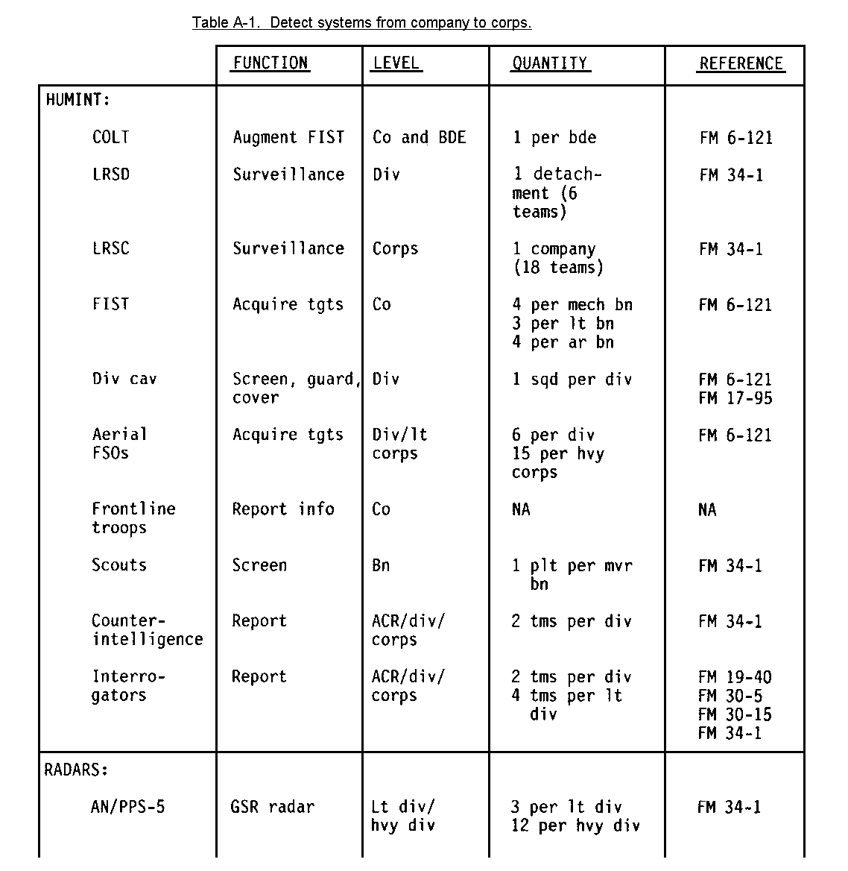

A-1
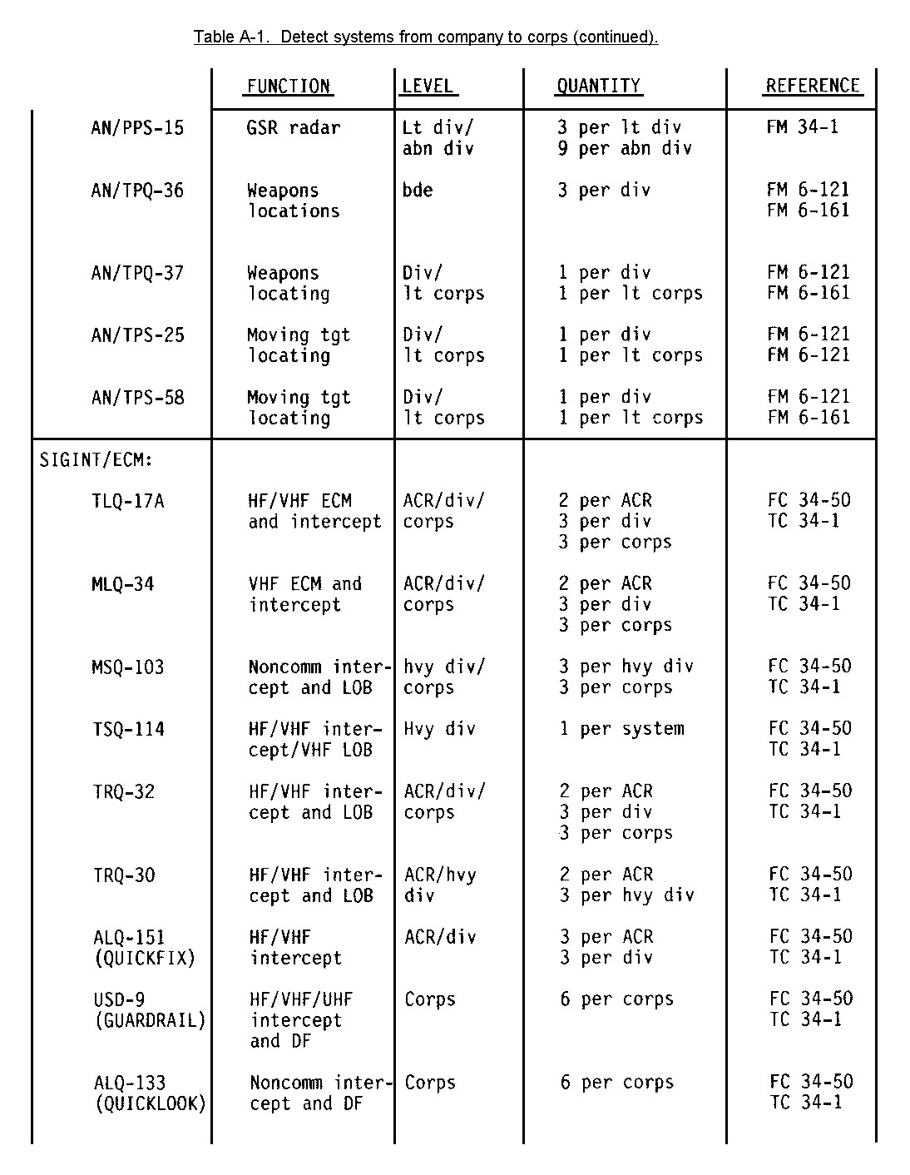A-2
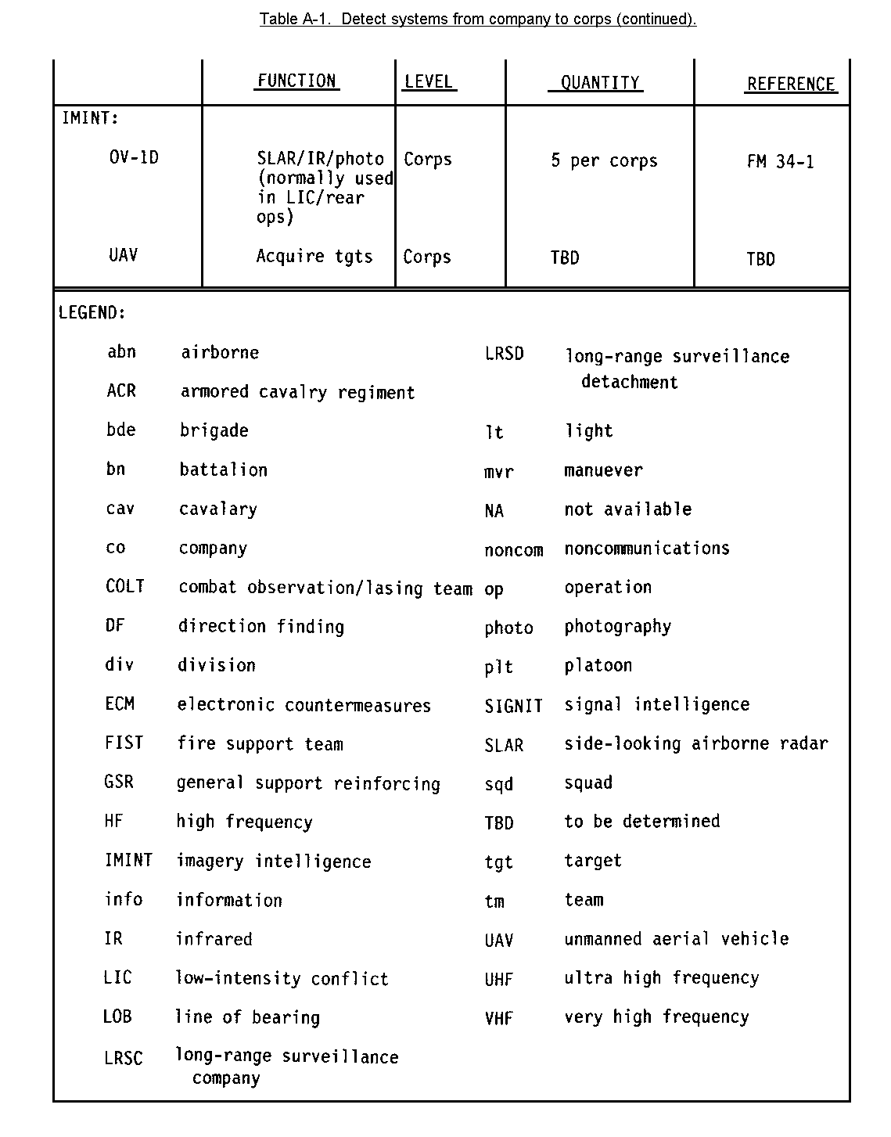

A-3
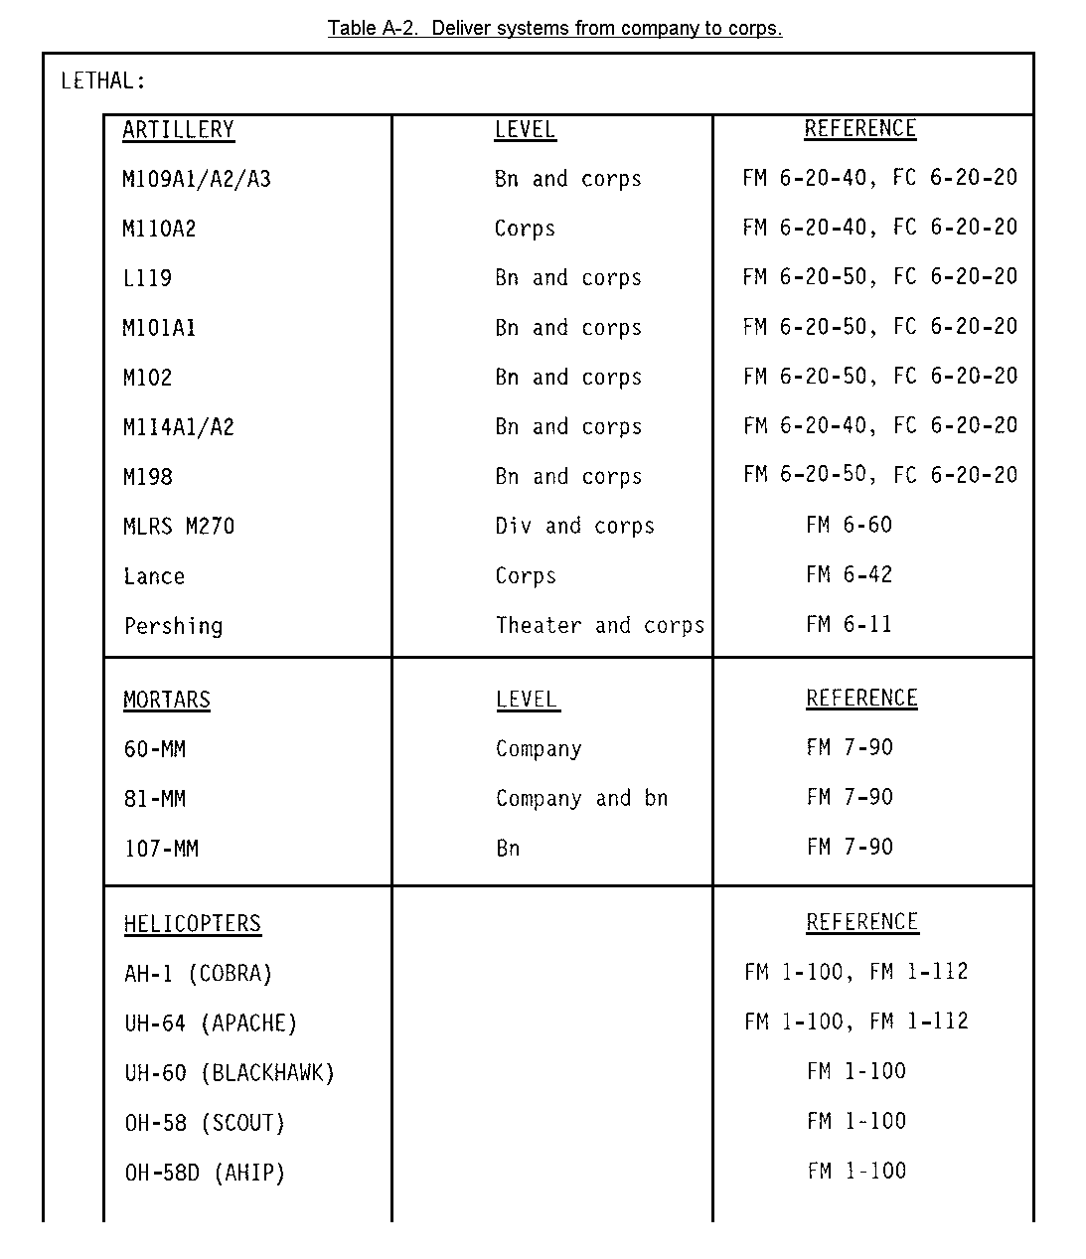

A-4
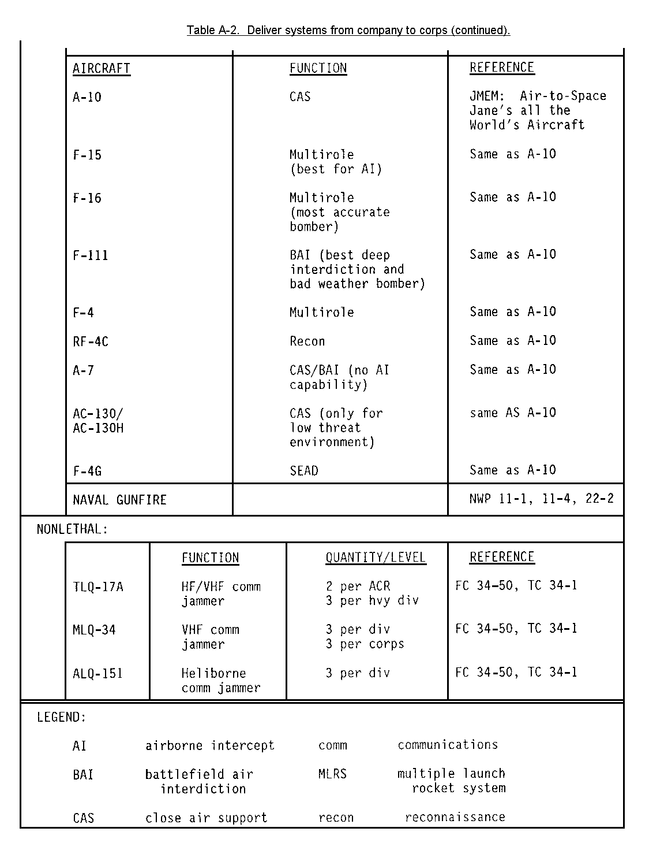
A-5

APPENDIX B

SPREAD SHEET

1. The title and sheet number specify the unit level and enemy mission of
interest. An example would be "Regiment Hasty Defense Number 5," which indicates the spread sheet for a maneuver regiment deployed in a hasty defense (see Figures B-1 and B-2). The header is located on the front and the back of the spread sheet.

2. The 13 target categories represent target groupings based on their
battlefield function, not the equipment associated with it. The categories (also known as sets) cover all of the major battlefield functions of the threat and are much more realistic and useful than the old eight-category grouping, where seven of the eight were related to counterfire or air defense targets.

a. C3 stands for command, control, and communications centers. These
refer generally to those targets that effect maneuver or combined arms command,
control, and communications. Examples include regimental, divisional, and army
command posts and traffic control points. There are currently 18 combined arms
command- and control-type high-value targets.

b. FIRE SPT refers to fire support targets and covers the entire threat
fire support system. Subsets include fire support command and control, weapons,
target acquisition, and ammunition logistics. There are a total of 24 fire
support high-value target types.

c. MANEUVER targets are maneuver tactical subunits in various postures.
There are motorized rifle and tank companies, assembly areas, march columns, and
advanced guard units. There are 10 maneuver unit high-value targets.

d. ADA stands for air defense system targets. These include missile unit
headquarters and processing centers, radar sites, and short-range air defense
platoons. There are 12 air defense high-value target.

e. ENGR refers to engineer-type targets. Examples include bridging,
ferry units and crossing sites, snorkeling sites, and movement support elements.
There are currently 11 engineer high-value targets with several others being
considered for addition in the TVA update.

f. RSTA is a grouping that contains reconnaissance, surveillance, and
target acquisition assets. This acronym refers to the Soviet concept where all
intelligence and TA collection assets are under the control of one manager at
each major unit level. Target types include ground surveillance radars,
reconnaissance patrols, and airborne sensor systems. There are five RSTA
targets.

g. REC stands for radio-electronic combat, commonly known in western
circles as offensive electronic warfare. Because of the nature of the Warsaw
Pact REC system, some dedicated collection target acquisition assets are listed
here instead of under RSTA. REC targets include communications and
noncommunications jammers, radio-radar direction finding stations, and airborne
jammers. There are 23 REC high-value target types.

B-1

h. NUC-CHEM are nuclear and chemical support elements and major weapon
firing positions. With the advent of the new nuclear-capable systems, this
category requires update for 152-mm caliber weapons. Nuclear and chemical
targets are always treated as a special case because of the destructive and
disruptive nature of the weapons that they support. There are seven of these
type high-value targets.

i. CL III indicates the target category that covers petroleum, oil, and
lubricant support. This category is critical because of the level of
mechanization of Warsaw Pact forces and their projected rates of advance for
second-echelon forces. Targets include transport and pipeline units and
petroleum, oil, and lubricants (POL) points. There are seven class-III
high-value targets.

j. CL V refers to ammunition support targets. These include ammunition
storage sites, depots, and distribution points. There are six ammunition target
types.

k. CL IX is the category that covers the maintenance and repair
capability for the Pact forces. These targets include regimental maintenance
units, vehicle collection points, and mobile repair facilities. There are four
targets in this category.

l. LIFT refers to general transport units in the opposing force. While
there is only one target category, special consideration should be given to
heliborne transport. This capability has increased considerably in the recent
past and will be critical for supporting airborne, airmobile, and ground forces
behind friendly lines.

m. LOC stands for lines of communication for which no specific target
types are designated. However, any target if attacked that would interfere with
the ground or air lines of communication is a candidate. Such targets would
include choke points, bridges, tactical airfields, and railheads.

3. The front of a spread sheet has four sections: the title and sheet number
identification data, the relative value matrix, the attack rationale column, and
the high-value target column.

4. The relative value matrix is a portion of the spread sheet that can be used
by commander, intelligence, and operations staffs as well as fire support
personnel at various stages in the targeting process. It indicates which of the
thirteen target sets are high value for the situation, and presents information
that aids managers of attack assets, (both maneuver and fire support) and aids
collection managers in establishing priorities. Commanders can use the matrix as a quick reference to what portions of the enemy array could best be attacked to support the operation.

a. The right side of the relative value matrix indicates the target sets
that are considered high value for the situation and presents their relative
value with respect to each other by using a simple bar chart. The target sets
that are not considered high value are not assigned a value bar and have a
uniform gray background.

B-2

b. The left side of the matrix consists of three columns labeled
"DISRUPT," "DELAY," and "LIMIT." A mark in the column, associated with a target
set, indicates that a benefit may be accrued by attacking the target with one of
these particular goals in mind.

(1) A mark in the DISRUPT column indicates that considerable benefit
can be gained by attacking a target with the goal of disrupting its function.
This could be achieved by continuous suppression, neutralization, or destruction
of the target by lethal means or could involve offensive electronic warfare for
some target types. The enemy function represented by the target is considered
unacceptable on the battlefield and must be removed.

(2) A mark in the DELAY column indicates that a benefit can be gained
by attacking the target to delay its arrival on the battlefield. In some cases a commander could opt to use a smaller amount of ammunition and slow a second
echelon force for a given period. This would free his remaining fire support
assets for a greater effort in the close-in battle. The delay afforded would
allow his maneuver forces to recover and refit and would allow a coordinated
effort when the second echelon finally arrived at the forward line of own troops
(FLOT). In this case, the unacceptable aspect of the target is its time of
arrival. The implication is that the combined arms team can defeat such a target given sufficient time to prepare.

(3) The LIMIT column, if marked, indicates that a benefit can be
gained if the target approach is limited. The desired effect, in this case, is a shunting of the enemy unit to another portion of the battlefield. This either
puts the target into a portion of the battlefield where it can be better handled
or puts the enemy on terrain not suitable to his purposes. This may be required
in the offense, if our forces are planning on using the route for the attack, and it is undesirable to have enemy forces on the route.

(4) Elements of a target set could conceivably be attacked to disrupt
their function, delay their arrival, and limit their approach, depending on the
target and the situation. This portion of the relative value matrix provides a
general guide to desired effects against a target and may remind planners that a
target need not be neutralized or destroyed to be rendered ineffective.

c. There is one target category that will always have the same relative
value at division level and above. Nuclear and chemical support target types
(Category 8) provide the opposing force with a capability that hazards any combat operation. The effects of nuclear and chemical weapons are often difficult to predict completely, further complicating the planning process and threatening the commander's concept. Such weapons should obviously be attacked with extreme vigor whenever they are found on the battlefield.

5. The attack rationale column in the center of the spread sheet provides
commander, operations elements, and fire support targeting personnel with a
general guide as to what benefits can be derived from attacking targets in a
particular category. This column discusses the desired objectives for attack of
the targets in the category. Descriptions are connected to their categories by
lines. Solid lines indicate the primary results of attacking targets in the
category from which it points (these lines should be traced from left to right).

B-3

Some descriptions are further attached to other categories by dotted lines. This indicates that a secondary benefit is achieved for that category when the primary category is attacked. These are traced from the attack rationale column back to the category (right to left).

a. There are two type styles used in the attack rationale column.
Boldface type indicates that the targets in their associated groups should be
attacked sequentially from the top of the matrix to the bottom. Generally, the
targets in these categories will give the greatest benefit if attacked in the
sequence indicated by the order of the descriptions. Descriptions in italics
indicates that for the enemy posture considered the categories always have the
same value throughout the operation.

b. Maneuver commanders should be familiar with the rationale for attacking
various types of targets so that their attack guidance will be completed and
accurate. Artillery commanders should be very familiar with the attack rationale to allow them to expand on the maneuver commander's guidance and to ensure that his detailed guidance stays within the TVA guidelines while providing optimum effects on the enemy formation.

c. Operations personnel can use the attack rationale column to help
develop the high-payoff target matrix and attack guidance. The categories that
are sequentially ordered should be prioritized and scheduled accordingly. Target categories whose attacks provide considerable secondary benefit should be
considered before single benefit categories with the same value.

6. The next portion of the spread sheet is the high-value target column that
specifies the high-value targets in each target set. For each category there are usually some high-value targets, even though the set itself might be given a low relative value. Fire planners and operations elements should use this portion of the spread sheet to recommend specific attack guidance and to develop the high-payoff target matrix for the operation. Targets are listed by the TVA sheet number and their name. Those using the spread to formulate detailed attack guidance should note all value categories. For example, when we are conducting pursuit operations, the enemy's engineer targets are a relatively low-value category. Mechanized minelayers, however, are high-value targets because if allowed to function, they can emplace minefields that could cause pursuing forces to lose contact. Targeting personnel should consider all of the high-value targets in the context of the situation, in addition to the commander's directives, before developing the high-payoff target matrix.

B-4
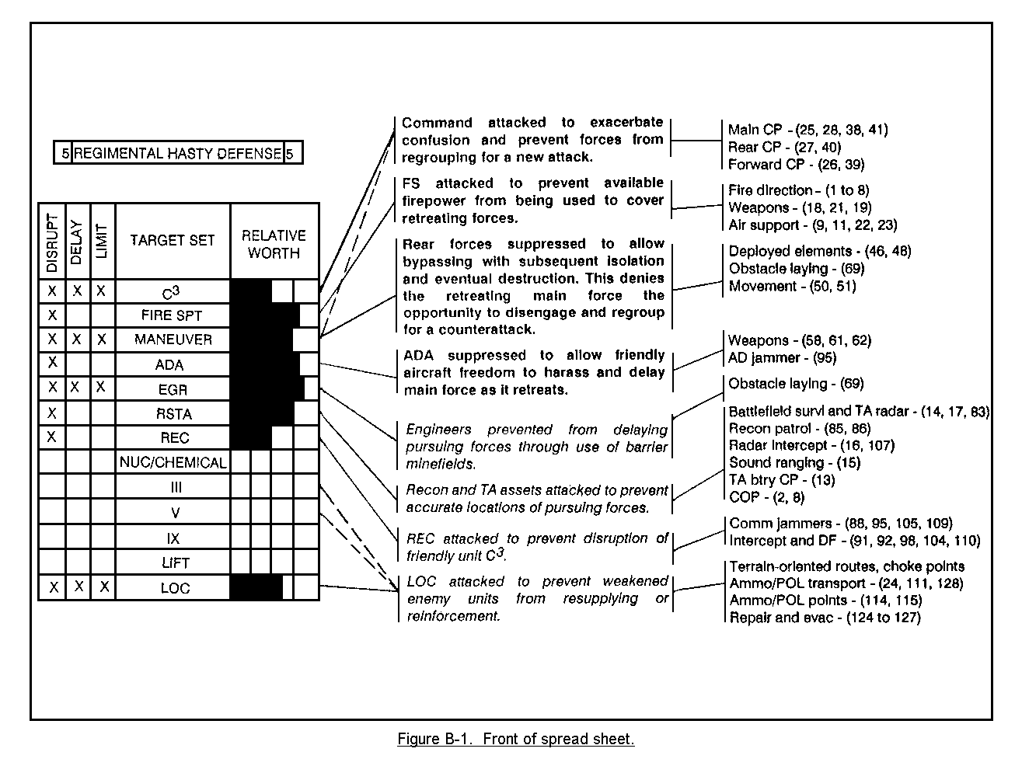

B-5
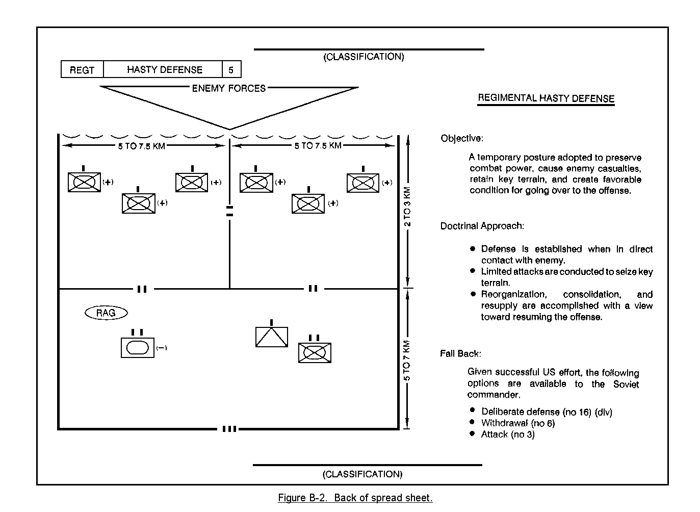

B-6

7. The back of the spread sheet is a summary of information about opposing
forces doctrine and tactics. The information presented is a Threat refresher for all personnel who play a part in the targeting process. It indicates how the threat is expected to fight and what their operation is intended to accomplish. It also indicates what we can expect the opposing force to do if it fails to accomplish its mission.

a. A doctrinal template indicates the major subunits of the unit
considered, deployed to scale, without regard to the effects of terrain and
weather. Collection managers and fire support personnel can use the template to
plan acquisition coverage and likely target areas of interest respectively.
These should be used cautiously because terrain can have great effect on actual
deployment. The doctrinal templates should only be used as a guide to predicting the deployment of opposing forces.

b. The doctrinal resume is a synopsis of the major features of the
operation. This portion indicates the objective of the force and the tactical
principles that govern how the unit is supposed to fight. Given the usual
penchant for Threat forces to use norms and detailed plans based on mathematical
formulas, this is an important part of the spread sheet for anyone contributing
to the targeting effort. The outline gives commanders and operations personnel a "window" into the minds of the opposing force commander and staff.

c. The fallback option portion details what we could expect the threat
forces to do if they failed to accomplish their mission. Planners should be
familiar with this portion to guide the development of their contingency plans.
High-payoff target recommendations can be prepared and presented to the commander on the basis of the most likely outcome of the current battle.

B-7

APPENDIX C

TARGET SHEET

1. The other tool that has been made available by target value analysis is the
target sheet (see Figure C-1). These sheets are simply fact sheets about the
target types referred to in the spread sheets. There is one target sheet for
each of the high-value targets, and they are numbered 1 through 128. They can be used by operations, intelligence, and other elements to answer questions about the acquisition and attack details.

2. The target sheet is made up of seven major sections: target category,
target title and number (incorrectly labeled high-payoff target), function,
description, signature, degradation effect, and some form of graphic
representation. The label "high payoff" is a misnomer in the original study and
really represents high value, as payoff is dependent on the tactical situation.
The amount of information under each section of the sheet varies considerably and should be available to fire support personnel as ready references. The sheets are classified SECRET-NOFORN, and many contain information available only from sensitive sources.

a. The target category will indicate to which of the 13 sets that the
target belongs. The sheet number can be used to cross-reference the target
sheet with the spread sheet. The title refers to the target unit type and
function. The other portions are more complex and contain most of the
information useful to targeting personnel.

b. The function section details the specific operations and tasks that the
target is expected to perform. They include the primary and secondary functions
of a target and will indicate any relationship to other target categories or
types.

c. The description of the target details the number and type of vehicles
and equipment in a position and will specify the approximate number of personnel
associated with the position. It will detail the usual distance from the forward edge of the battlefield. It will indicate the normal posture of the target with respect to camouflage and orientation as well as the amount and type of terrain occupied. The description is useful when considering what types of attack systems and munitions to be used.

d. The signature section is especially useful to target acquisition
collection managers. The signatures described range from visual and electronic
to auditory and infrared.

e. The degradation portion indicates what happens to the parent or an
associated unit when the target function is removed. This section can be used
by operations and fire support personnel to help determine effects desired
against a target.

C-1
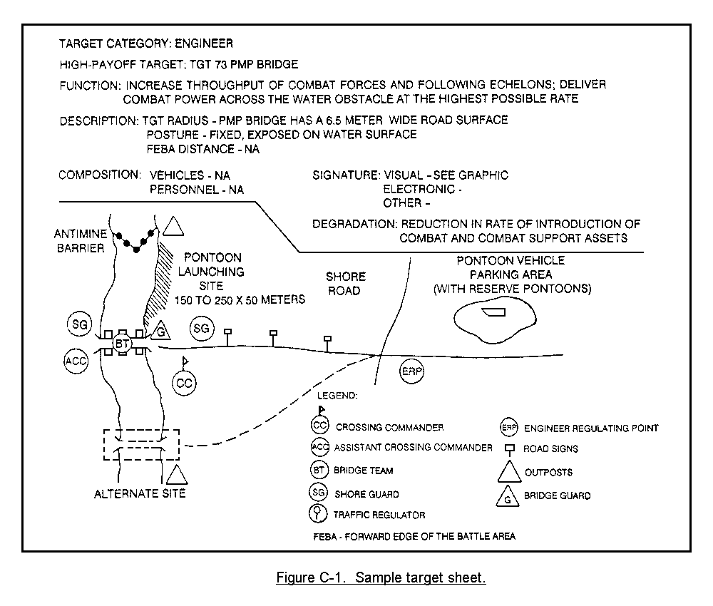

C-2

APPENDIX D

HIGH-PAYOFF TARGET MATRIX

1. As a part of the preparation of estimates that support the development of
the commander's concept of the operation, the G2, G3, and the FSCOORD (or their
designated representatives) must set down and present the commander with their
estimates of high-payoff target matrix. (See Figure D-1.)

2. After the commander has approved the high-payoff target matrix, it then
forms the guide for the collection and attack manager's production of orders and
taskings.

3. The priority indicates which of the target types are the most important in
order of rank, on the basis of the enemy and friendly situation. The category
column indicates the target category or categories from which the target types
are taken.

D-1
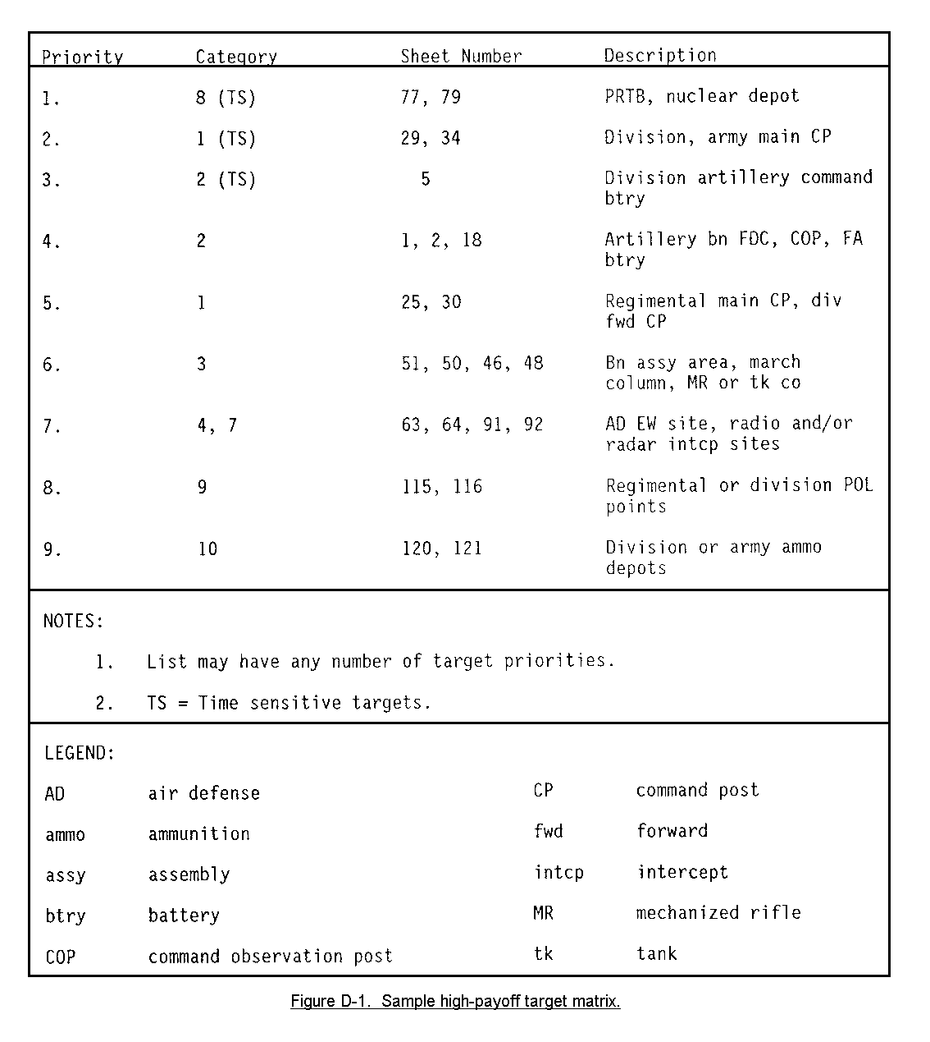

D-2

APPENDIX E

ATTACK GUIDANCE MATRIX

1. After the approval of the high-payoff target matrix, the operations and fire support personnel should establish attack guidance for approval by the commander. The attack guidance is used to distribute fires on the battlefield. (See Figure E-1 for a sample attack guidance matrix.)

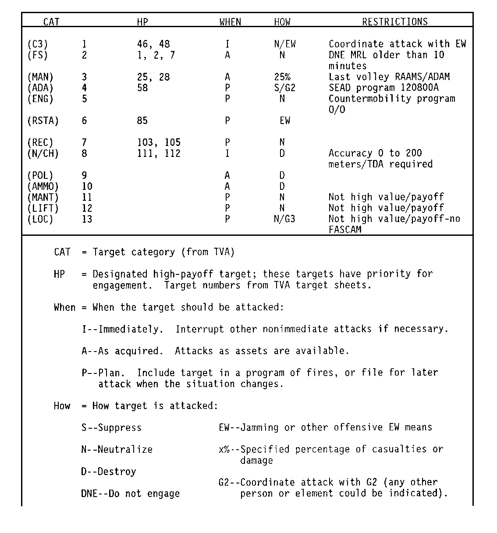
E-1
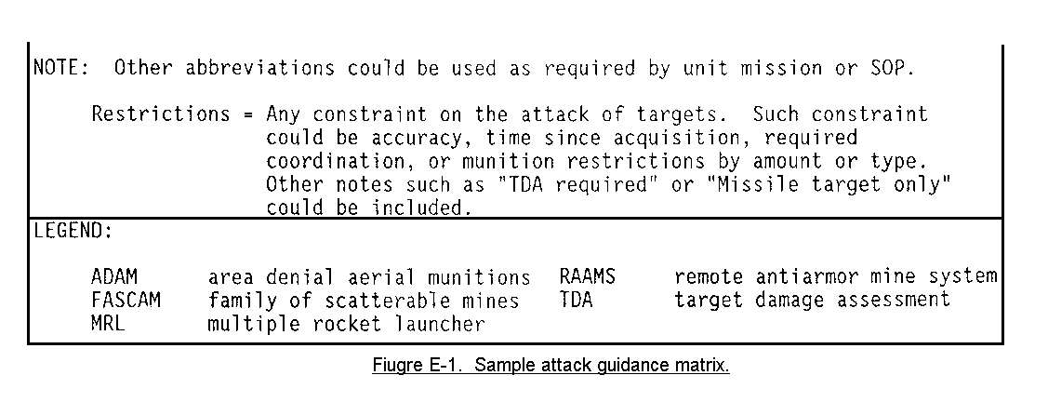

NOTE: This is only a sample attack guidance matrix. Actual matrixes will be
developed by the G3 or S3 and the FSE on the basis of the tactical
situation.

2. The target categories indicated are in the order that they are presented in
the relative value matrix of the spread sheet. These should not be reordered
every time the matrix is produced. If certain categories are especially high
payoff in a particular situation, these may be noted by a color code or asterisk.

3. The high-payoff target column indicates those targets, by target sheet
number, that have been designated on the high payoff target list. Fire support
personnel can refer to the priority listing of the high-payoff matrix when the
target comes in to determine the urgency of response.

4. The HOW column refers to the desired effects or nature of the attack on the
target. Fire support and operations personnel should specify these effects
within the constraints of the division commanders and division artillery
commanders general guidance. Desired effect can be specified by a subjective
term; for example, suppress, neutralize, or destroy. They also can be indicated
by a percentage of casualties or destroyed elements and can be noted as a number
of battery or battalions volleys. A coordinated attack is one that requires
coordination with another agency (G2, G3, USAF) before attacking with destructive weapons. This may be required to allow intelligence to be gathered or to preclude conflicts.

5. The WHEN column indicates when a target should be attacked.

a. An entry of P in this column indicates that a target should not be
engaged now, but should be planned for future fire (for example, anticipated
preparation, SEAD program, countermobility program) or simply put on file.

b. An entry of A stands for as acquired. Such targets should be engaged
in the sequence that they are received in the headquarters, with respect to the
priority noted in the high-payoff target list.
E-2

c. Immediate (I) attacks are a special case. Such targets should be
limited to a very small percentage of targets and only for the most critical
types. Too many immediate targets will be disruptive and will lower the
efficiency of attack systems. Immediate attacks are those that take precedence
over all others and interrupt attacks already under way. Some examples of very
important targets include nuclear-capable missile systems, division headquarters, and nuclear weapon storage and support facilities. Multiple rocket launchers may be considered for immediate attack, depending on their demonstrated effectiveness against our forces and their tactical employment. The div arty S4 must establish procedures that allow for immediate attacks of targets but that do not seriously degrade the efficiency of the system.

6. Restrictions are any constraint or special modification of attacks. This
column should be used to note accuracy or time constraints and limitations on
the amount or type of ammunition. This column should note which target
categories are not high value and which targets should not be attacked on the
basis of certain tactical situations (for example, targets not to be attacked if
enemy is withdrawing).

7. It is important that the operations and fire support elements work closely
together to convert the commander's desires and requirements into specifications
for the fire support system. The attack guidance should be clear and unambiguous to ensure rapid, positive responses to targets.

E-3

APPENDIX F

TARGET SELECTION STANDARDS MATRIX

1. Target selection standards are criteria by which personnel can determine
which targets are valid fire support targets and which require some form of
confirmation before they can be considered for attack. Target data are divided
into two categories--targets and suspect targets.

2. Target selection standards are dynamic (and for FA TA assets are approved by the div arty S3). They are keyed to the tactical situation with the greatest
emphasis on the enemy situation with respect to deception and the reliability of
the source or agency that is reporting. Target selection standards are designed
to allow targeting personnel in the TOC to readily distinguish between targets
and suspect targets. The intelligence officer or his staff also should produce
TSS for his organic assets for similar reasons.

3. Target selection standards must be developed because the enemy deception
effort will vary in scope and intensity throughout the battle. Elements of the
enemy deception capability include:

- Dummy positions.
- Corner (radar) reflectors (against general support reinforcing (GSR).

- moving-target-locating radar (MTLR).

- Camouflage (both real and dummy positions).

- Deceptive and imitative communications.

- Sound or flash simulators.

- Roving and offset guns.

- Feints and ruses.

- Loudspeaker broadcasts.

- False data plants (operational-tactical disinformation).

4. The sample target selection standards (Figure F-1) indicate that weapons-
locating radar; unmanned aerial vehicle (UAV); FA aerial observers 1, 3, 4;
sound ranging; three correlated crater rays; and one crater ray correlated with a grid-producing source all produce targets. Moving-target-locating radars and
combat observation/lasing teams (COLTs) are noted as producing a suspect target,
as is field artillery aerial observer (FAAO) 2.

F-1
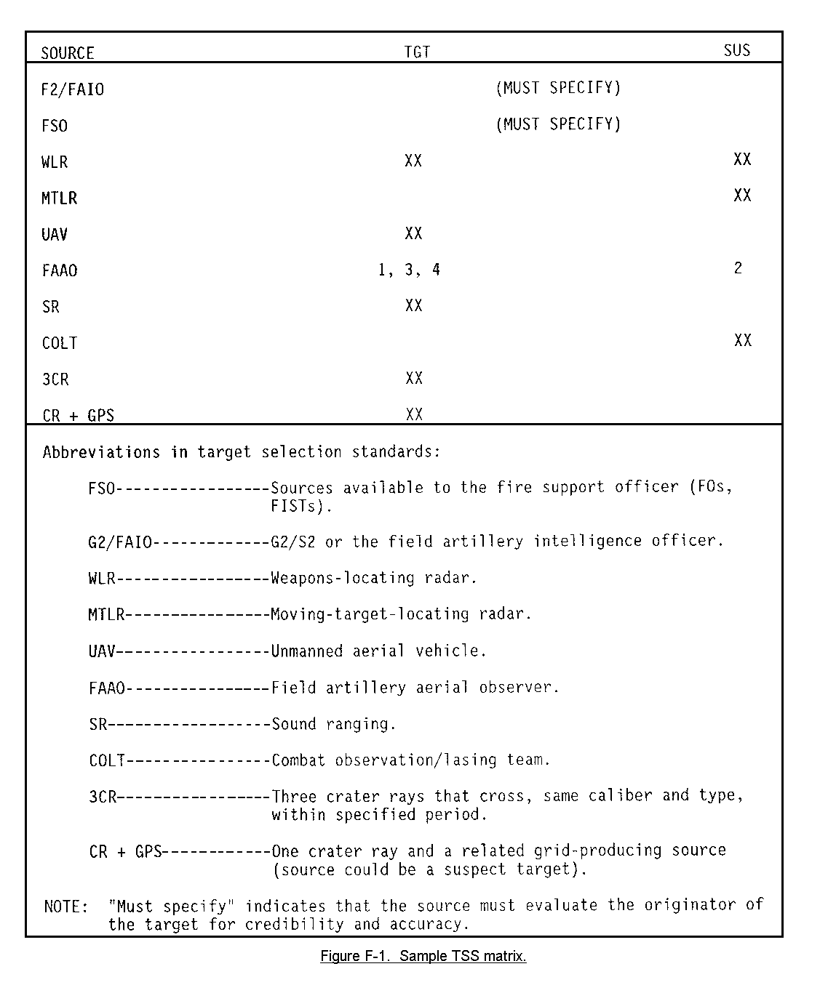

F-2

5. Numbers in the FAAO column indicate individual observers (call signs could
be specified). The difference in their status could result from a variation in
the tactical situations in their area, or individual ability to overcome
deceptive measures. (This rationale also pertains to other sources).

6. Targeting information from the intelligence community and from fire support
elements are marked "MUST SPECIFY" because of the nature of the reporting
agencies. Each of these sources has numerous reporting agencies (external to the TOC) that only they can evaluate for accuracy of location and identification. As a result, if information is generated within one of these areas and is then reported to the TOC, the reporting agency must specify target or suspect target status.

F-3

APPENDIX G

DOCTRINAL TEMPLATE

The doctrinal template is a graphic depiction of how the enemy would deploy
his forces if he were not constrained by the weather or terrain. This template
is developed for the specific threat and the type of operation that unit is
expected to conduct. An example of a template that would be developed is a
motorized rifle regiment in prebattle formation (see Figure G-1). The doctrinal
template provides basic information such as the composition, frontages,
dispersal, and order of march for the threat force. The intelligence officer
will produce the bulk of these templates but he is assisted by the other members
of the combined arms team. Each staff officer contributes information regarding
his specific area of expertise. While the doctrinal template leaves many
questions unanswered, it provides a basis for the FSO to begin fire planning.

G-1
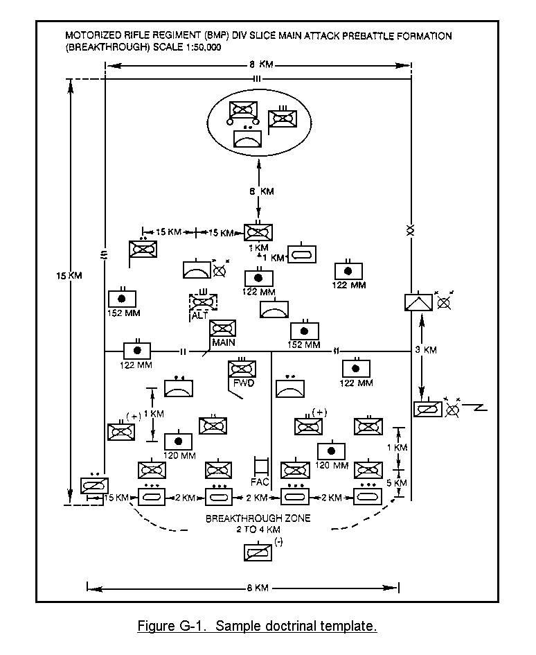

G-2

APPENDIX H

SITUATION TEMPLATE

The situation template builds on the information provided by the doctrinal
template by adding the effects of weather and terrain. To develop the situation
template, the doctrinal template is laid over the map of the battlefield. The
frontages, dispositions, and dispersal patterns are then adjusted to compensate
for the effects of weather and terrain provided by the terrain analysis or
combined obstacle overlays. Each mobility corridor within each avenue of
approach is analyzed. A series of situation templates provides "snapshots" of
how we can expect the enemy force to move across the battlefield (see Figures
H-1 to H-3). The field artilleryman's contribution to this template is the
adjustment of the enemy fire support asset deployment for the weather and terrain effects. Obviously, the situation template provides much better information than the doctrinal template and serves as a basis for the intelligence collection plan, target acquisition plan, and the fire support plan.

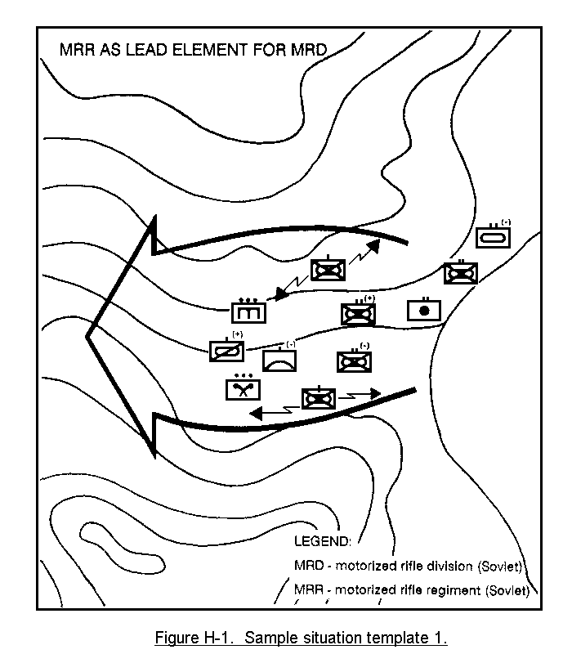

H-1
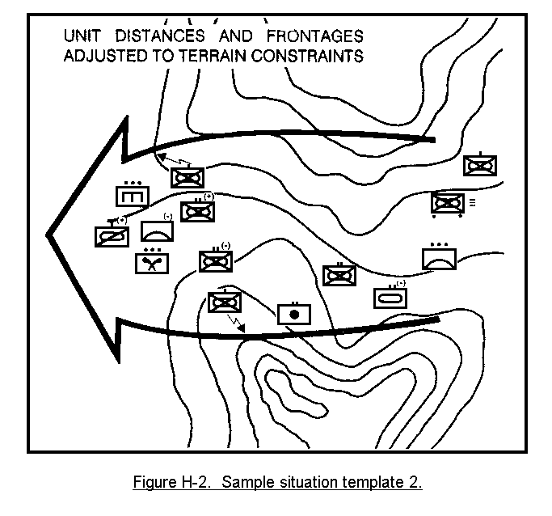
H-2
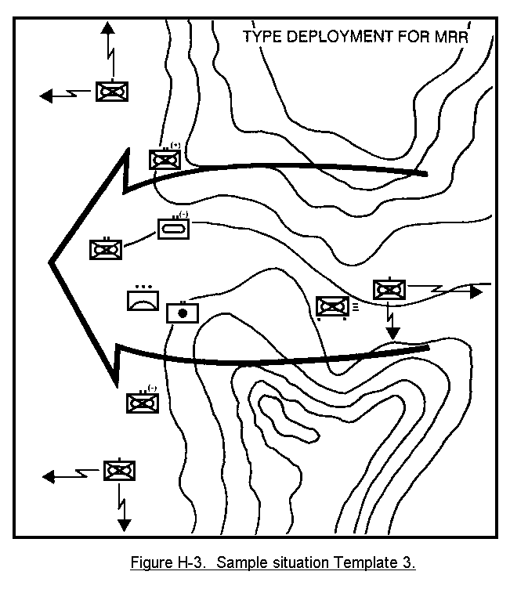

H-3

APPENDIX I

EVENT TEMPLATE

1. Just as the doctrinal template was further developed into situation
templates, the situation templates provide the basis for the event template (see
Figure I-1). The event template identifies and analyzes significant events and
enemy activities that occur (designated as named areas of interest). An NAI is
an area where enemy action or lack of action will either confirm or deny that the enemy is pursuing a particular course of action. Event templates are developed by war-gaming each enemy course of action to the probable objectives. Time lines depicting the enemy's doctrinal movement rate, adjusted by the effects of weather and terrain, are added to the template.

2. An event analysis matrix is then prepared for each mobility corridor
identified on the event template (see Figure I-2). The event analysis matrix
adds the dimension of time and correlates the NAIs within the mobility corridor.
An estimation of the time required for the enemy to move from one NAI to the next is provided on the matrix.

3. The event template and event analysis matrix focus the friendly collection
resources against the targets and areas that will provide the greatest benefit.
The event template tells us where to look, when to look, and what to look for.
The focus provided by the event template enables the FSO to develop a precise
target acquisition plan to complement the intelligence officer's collection plan. A close relationship between the FSO and intelligence officer is necessary to ensure efficient coverage of all NAIs.

I-1
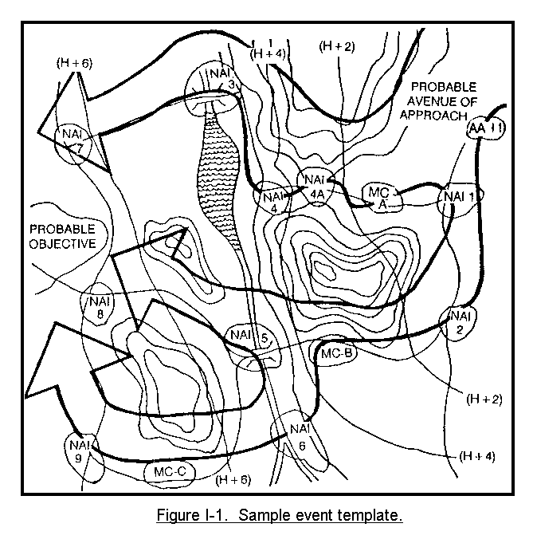

I-2

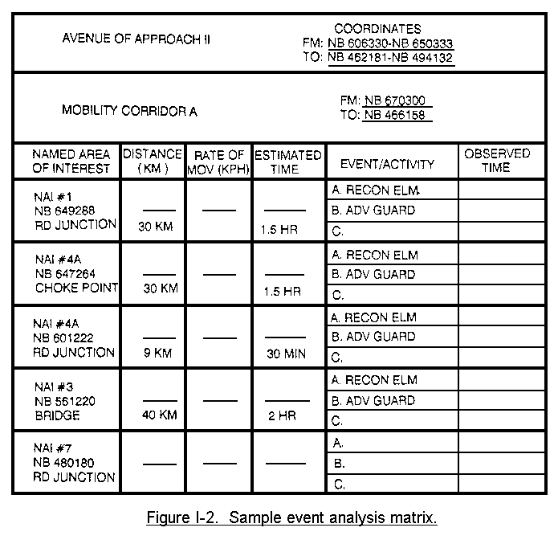

I-3

APPENDIX J

DECISION SUPPORT TEMPLATE

1. The final template in the IPB process is the decision support template (see
Figure J-1). It integrates the event template with the mission of the friendly
force and with the commander's intent and concept of the operation. It
identifies critical events and threat activities in relation to times and
locations that may require a tactical decision by the commander. The decision
support template is developed in the war-gaming portion of the decision-making
process.
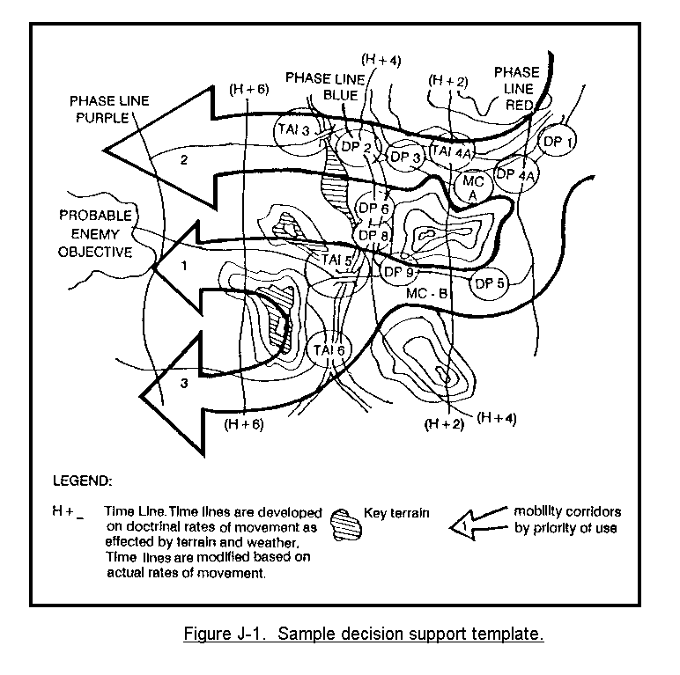

J-1

2. Decision support templating identifies the areas where enemy or terrain
targets can be attacked to support the commander's concept of the battle. Areas
where the commander can influence the action through fire and maneuver are
identified along each avenue of approach and mobility corridor. These areas are
designated as target areas of interest. Usually the TAIs were identified
earlier as NAIs. A TAI is an area where we can destroy, disrupt, delay, or
otherwise manipulate the enemy force. A TAI is also a suitable location for the
attack of high-value targets.

3. TAIs are significant because--

a. They provide a basis for the allocation of deep attack resources.

b. If the target fails to appear at that critical area, then the event or
course of action we expected may not occur.

c. They are the basis of combat power determination along the different
mobility corridors. By engaging the enemy early, we can influence the combat
power he can exert on a specific mobility corridor and thereby allow our
commander to control the close battle.

4. The intelligence, maneuver, and fire support staffs jointly develop the
TAIs. The intelligence staff evaluates the enemy force and the effects of
friendly action on them. The maneuver and fire support staffs determine--

a. What attack assets will be available.

b. What effect interdiction of the enemy at the selected TAIs will have on
the accomplishment of our mission.

c. What the priorities for the attack assets will be.

5. Once the TAIs have been agreed upon, decision points are selected. Decision points identify specific battlefield events which may require a decision by the friendly commander and identify when the decision is required. Decision points equate time to specific point on the battlefield. The time factor includes the enemy's movement rate, the distance to be traveled, and the time it takes us to carry out a decision. Because the location of decision points is dependent on the availability and capability of friendly fire and maneuver assets, the G3/S3, aided by the FSO, will make the decision.

6. The decision support template, which depicts the TAIs and decision points,
may be supplemented by a decision support matrix (see Figure J-2). The matrix
associates each decision point to its related TAI or event. It provides the
commander with the time and location of forces that will cause him to make a
decision if he is to exercise the options he has available to him.

J-2
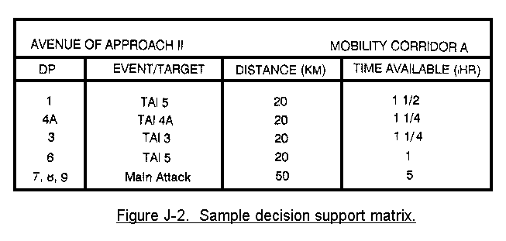

7. For the FSO, the decision support template serves another purpose. By
knowing the expected time of the enemy force arrival, the FSO can define trigger
points to initiate key missions, such as a group or series or to cover an
obstacle with fire.

8. The decision support template is one of the most important documents the
FSO can obtain. It provides the intelligence estimate in graphic form, target
acquisition guidance, target locations and priorities, and the information
necessary to determine the fire support tasks for the operation. Most important, however, is the understanding of the commander's intent and concept of operation gained by participating in the war-gaming process. Without the information gained from the decision support template, an FSO will depend more on luck than skill to develop a fire support plan that is fully synchronized with the scheme of maneuver.

9. Commander's and their staffs have always tried to visualize the enemy's
intentions. In addition, commanders have evaluated the military aspects of
terrain and have used the weather to their advantage against the enemy. The IPB
process has refined the old methods into a systematic process that uses
graphics.

10. The effective integration and synchronization of indirect fires will best be accomplished by detailed planning and coordination on the basis of an
intelligent analysis of all available information. As artillerymen, we must be
involved with the IPB, as it alone provides for the intelligent preparation of
the battlefield.

J-3

